HO CHI MINH CITY UNIVERSITY OF TECHNOLOGY AND EDUCATION

FACULTY OF INTERNATIONAL EDUCATION


GRADUATION PROJECT

VERIFICATION FOR 5-STAGE PIPELINED
RISC-V RV32I USING UVM-BASED PLATFORM

TRAN VAN DU
Student ID: 18119012
DANG NGUYEN BAO LAM
Student ID: 19161070

Major: COMPUTER ENGINEERING

Advisor: PHAM VAN KHOA, PhD.

Ho Chi Minh City, June 2024

HO CHI MINH CITY UNIVERSITY OF TECHNOLOGY AND EDUCATION

FACULTY OF INTERNATIONAL EDUCATION


GRADUATION PROJECT

VERIFICATION FOR 5-STAGE PIPELINED
RISC-V RV32I USING UVM-BASED PLATFORM

TRAN VAN DU
Student ID: 18119012
DANG NGUYEN BAO LAM
Student ID: 19161070

Major: COMPUTER ENGINEERING

Advisor: PHAM VAN KHOA, PhD.

Ho Chi Minh City, June 2024

 | THE SOCIALIST REPUBLIC OF VIETNAM  Independence – Freedom– Happiness  --------  Ho Chi Minh City, June 24, 2024

GRADUATION PROJECT ASSIGNMENT

Student name: TRAN VAN DU | Student ID: 18119012
Student name: DANG NGUYEN BAO LAM | Student ID: 19161070
Major: COMPUTER ENGINEERING TECHNOLOGY
Advisor: Pham Van Khoa | Phone number: _________________
Date of assignment: _____________________ | Date of submission: _____________
1. Project title: VERIFICATION FOR 5-STAGE PIPELINED RISC-V RV321 USING UVM BASED PLATFORM
2. Initial materials provided by the advisor: ___________________________________
3. Content of the project: Build a UVM test bench environment to test and verify functionality for the basic RISC-V RV32I architecture.
4. Final product: Create testcases and run simulations on the UVM testbench environment to test the functionality of the RV32I RTL design.
CHAIR OF THE PROGRAM  (Sign with full name) | ADVISOR  (Sign with full name)

 | THE SOCIALIST REPUBLIC OF VIETNAM  Independence – Freedom– Happiness  --------  Ho Chi Minh City, June 24, 2024
ADVISOR’S EVALUATION SHEET

Student name: TRAN VAN DU Student ID: 18119012
Student name: DANG NGUYEN BAO LAM Student ID: 19161070
Major: COMPUTER ENGINEERING TECHNOLOGY
Project title: VERIFICATION FOR 5-STAGE PIPELINED RISC-V RV321 USING UVM BASED PLATFORM
Name of Advisor: Pham Van Khoa
EVALUATION
1. Content and workload of the project
……………………………………………………………………………………………….
2. Strengths:
……………………………………………………………………………………………….
3. Weaknesses:
……………………………………………………………………………………………….
4. Approval for oral defense? (Approved or denied)
……………………………………………………………………………………………….
5. Overall evaluation: (Excellent, Good, Fair, Poor)
Good
6. Mark: …….. (in words: ………………)
Ho Chi Minh City, month date, 2024
ADVISOR
(Sign with full name)

 | THE SOCIALIST REPUBLIC OF VIETNAM  Independence – Freedom– Happiness  --------  Ho Chi Minh City, July 2, 2024

PRE-DEFENSE EVALUATION SHEET

Student name: TRAN VAN DU Student ID: 18119012
Student name: DANG NGUYEN BAO LAM Student ID: 19161070
Major: COMPUTER ENGINEERING TECHNOLOGY
Project title: VERIFICATION FOR 5-STAGE PIPELINED RISC-V RV321 USING UVM BASED PLATFORM
Name of Reviewer: Vo Minh Huan
EVALUATION
1. Content and workload of the project
Thesis applies UVM testbench technique in the testing and verification process for RV32I design. Then, the RTL design and UVM testbench will be evaluated and analyzed.
2. Strengths:
The UVM testbench technique is an industry standard test method for verifying the digital IC circuits. Authors has analyzed this technique very clear and apply it to verify some blocks of RISC-V. RISC-V is analyzed and verified by using UVM technique.
3. Weaknesses:
Authors should analyze more detail in blocks of 5-stage pipelined RISC-V. Behavior simulation should be included in thesis to verify the functionality of RISC-V.
4. Approval for oral defense? (Approved or denied)
Approved
5. Overall evaluation: (Excellent, Good, Fair, Poor)
Good
6. Mark: 8.2/10 (in words: Eight point two)
Ho Chi Minh City, July 2, 2024
REVIEWER
(Sign with full name)

Vo Minh Huan

 | THE SOCIALIST REPUBLIC OF VIETNAM  Independence – Freedom– Happiness  --------  HoChiMinh City, July 1 ^{st} , 2024

PRE-DEFENSE EVALUATION SHEET

Student name: TRAN VAN DU Student ID: 18119012
Student name: DANG NGUYEN BAO LAM Student ID: 19161070
Major: COMPUTER ENGINEERING TECHNOLOGY
Project title: VERIFICATION FOR 5-STAGE PIPELINED RISC-V RV321 USING UVM BASED PLATFORM
Name of Reviewer: LE MINH THANH, M.Eng.
EVALUATION
1. Content and workload of the project
- Including verification of the 5-stage pipelined RISC-V RV321 architecture using the UVM-based platform. Each sub-block is fully testbenched with a specific testcase.
2. Strengths:
- Explanation of figures in the thesis is clear and mapping to the requirements.
3. Weaknesses:
- The similarity rate of 22%.
- All numbered figures are incorrect.
4. Approval for oral defense? (Approved or denied)
- Approved.
5. Overall evaluation: (Excellent, Good, Fair, Poor)
- Good.
6. Mark: 8.0 (in words: Eight)
HoChiMinh City, July 1 ^{st} , 2024
REVIEWER

Le Minh Thanh
DISCLAIMER

We hereby declare that this thesis, titled "VERIFICATION FOR 5-STAGE PIPELINED RISC-V RV321 USING UVM-BASED PLATFORM", represents our original work conducted under the guidance of Dr. Pham Van Khoa. The simulations, study findings, and conclusions presented in this thesis are accurate to the best of our knowledge and have not been replicated from any other sources.
We have meticulously cited and referenced all sources used in the preparation of this thesis. We acknowledge the contributions of others and take full responsibility for any errors or omissions. This thesis is submitted in partial fulfillment of the requirements for the degree of Bachelor at Ho Chi Minh University of Technology and Education.
We affirm that this work adheres to the academic integrity standards set forth by Faculty of International Education, and Ho Chi Minh University of Technology and Education. We understand the consequences of plagiarism and academic dishonesty, and we pledge that this thesis represents our own independent work.
Student
TRAN VAN DU DANG NGUYEN BAO LAM

ACKNOWLEDGEMENTS

First and foremost, we would like to thank the Faculty of International Education and the School Board of the Ho Chi Minh City University of Technology and Education for providing the right environment for me to pursue my project.
Furthermore, we would like to express our heartfelt appreciation to the department's head, Ph.D. Pham Van Khoa, who constantly monitors the learning environment and supports and develops growth opportunities for each student generation.
Finally, a lack of experience and sluggish implementation prevent us from avoiding mistakes. Your feedback and suggestions are appreciated as we continue to improve this topic.
Regards, and many thanks for your support.

Student
TRAN VAN DU DANG NGUYEN BAO LAM

TABLE OF CONTENTS

CHAPTER 1: INTRODUCTION 14
1.1 Introduction 14
1.2 Objective 14
1.3 Limitation 15
1.4 Research method 15
1.5 Object and the scope of the study 15
1.6 Outline 15
CHAPTER 2: LITERATURE REVIEW 16
2.1 RISC-V Introduction 16
2.1.1 RISC-V 32 Instruction Set Architecture 16
2.1.1.1 RV32I Instruction Formats 18
2.1.1.2 RV32I Encoding Variants 19
2.1.1.3 RV32I Integer Register-Immediate Instructions 20
2.1.1.4 RV32I Integer Register-Register Operations 21
2.1.1.5 RV32I NOP Instruction 22
2.1.1.6 RV32I Unconditional Jumps 22
2.1.1.7 RV32I Conditional Branches 24
2.1.1.8 RV32I Load and Store Instructions 24
2.1.2 RV32I Components 25
2.1.3 RV32I Pipeline 27
2.2 Universal Verification Methodology 27
2.2.1 UVM Testbench Architecture 27
2.2.2 UVM Component Class 29
2.2.2.1 UVM testbench top 30
2.2.2.2 UVM test 32
2.2.2.3 UVM environment 34
2.2.2.4 UVM agent 36
2.2.2.5 UVM driver 37
2.2.2.6 UVM monitor 39
2.2.2.7 UVM scoreboard 41
2.2.3 UVM Transaction Base Class 42
2.2.3.1 UVM sequence item 43
2.2.3.1 UVM sequence 43
2.2.4 UVM phase 44
CHAPTER 3. IMPLEMENTATION 45
3.1 RV32I Implementation 45
3.1.1 The Program Counter module 45
3.1.2 The Instruction Memory module 45
3.1.3 The Register File module 46
3.1.4 The Arithmetic Logic Unit module 47
3.1.5 The ALU Control module 48
3.1.6 The Control Unit module 48
3.1.7 The Data Memory module 49
3.1.8 The Immediate Generation module 50
3.1.9 The Immediate Address module 51
3.1.10 RV32I Pipeline 52
3.2 RV32I Verification 55
3.2.1 Verification plan 55
3.2.2 Testbench implementation 56
3.2.2.1. Testbench flow 56
3.2.2.3. Test scenario 57
3.2.2.3.1 Directed testcase 57
3.2.2.3.2 Randomized testcase 58
3.2.2.3.3 ASM simulation testcase 59
3.2.3 RV32I UVM component implementation 60
3.2.3.1 RV32I sequence 60
3.2.3.2 RV32I driver 61
3.2.3.3 RV32I monitor 62
3.2.3.4 RV32I agent 63
3.2.3.5 RV32I environment 63
3.2.3.6 RV32I test 64
3.2.3.7 RV32I interface 65
3.3.3.8 RV32I scoreboard 67
3.2.3.9 RV32I testbench top 69
3.2.4 RV32I instruction code generation 70
3.2.5 RV32I reference model impletation 71
3.2.5.1 Program counter reference model 71
3.3.5.2 Immediate memory reference model 73
3.3.5.3 Register file reference model 74
3.2.5.4 Control unit reference model 75
3.2.5.5 Immediate generation reference model 76
3.2.5.6 ALU control reference model 77
3.2.5.7 Data memory reference model 78
3.2.6 DUT-Testbench Connections. 79
CHAPTER 4. RESULT 81
4.1 Design error detection 81
4.2 Directed testcase 82
4.3 Random testcase 84
CHAPTER 5. CONCLUSION AND FUTURE WORK 89
5.1 Conclusion 89
5.2 Future Work 89
REFERENCE 90

LIST OF FIGURES

Figure 1: RISC-V base unprivileged integer register state. 17
Figure 2: RV32I formats. 18
Figure 3: RV32I formats with immediate variants. 19
Figure 4: RV32I type of immediate 19
Figure 5: I-type Basic instructions 20
Figure 6: I-type Shift instructions 21
Figure 7: U-type Basic instructions 21
Figure 8: R-type Basic instructions 22
Figure 9: I-type NOP instruction 22
Figure 10: J-type JAL instruction 23
Figure 11: J-type JALR instruction 23
Figure 12: B-type Branch instructions 24
Figure 13: I-type LOAD instruction 25
Figure 14: S-type STORE instruction 25
Figure 15: RV32I processor block diagram(Patterson and Hennessy, 2017) 26
Figure 16: UVM Testbench Architecture 28
Figure 17: UVM hierarchy 29
Figure 18: UVM component hierarchy 29
Figure 19: UVM testbench top in UVM 31
Figure 20: UVM testbench top hierarchy 31
Figure 21: UVM test in UVM 33
Figure 22: UVM test hierarchy 34
Figure 23: UVM env in UVM 35
Figure 24: UVM env hierarchy 35
Figure 25: UVM agent in UVM 36
Figure 26: UVM agent hierarchy 37
Figure 27: UVM driver in UVM 38
Figure 28: UVM driver hierarchy 39
Figure 29: UVM monitor in UVM 40
Figure 30: UVM monitor hierarchy 40
Figure 31: UVM scoreboard in UVM 41
Figure 32: UVM scoreboard hierarchy 42
Figure 33: UVM transaction hierarchy 42
Figure 34: UVM sequence in UVM 43
Figure 35: UVM phase step 44
Figure 36: RV32I Program Counter block diagram (Patterson and Hennessy, 2017) 45
Figure 37: RV32I Instruction Memory block diagram(Patterson and Hennessy, 2017) 46
Figure 38: RV32I Instruction Memory block diagram(Patterson and Hennessy, 2017) 47
Figure 39: RV32I Instruction Memory block diagram (Patterson and Hennessy, 2017) 47
Figure 40: RV32I Instruction Memory block diagram (Patterson and Hennessy, 2017) 48
Figure 41: RV32I Data Memory block diagram (Patterson and Hennessy, 2017) 50
Figure 42: RV32I Immediate Generation block diagram(Patterson and Hennessy, 2017) 51
Figure 43: Pipelining breaks the critical path segregating the combo logic and adding registers in between classic RISC-V stages 52
Figure 44: Multiple Instructions executed with Pipeline Implementation 53
Figure 45: the concept of separating the datapath flow into several stages 53
Figure 46: Pipelined Datapath with Control Elements integrated 54
Figure 47: RV32I UVM Testbench Architecture 55
Figure 48: UVM flow chart 56
Figure 49: Code of uvm sequence item 58
Figure 50: Code random test in uvm sequence item 59
Figure 51: RV32I UVM hierarchy 60
Figure 52: Sequence flow 60
Figure 53: RV32I_driver code 61
Figure 54: RV32I_driver code 62
Figure 55: RV32I_monitor code 62
Figure 56: RV32I_agent code 63
Figure 57: RV32I_env code 64
Figure 58: RV32I_test code 65
Figure 59: RV32I interface code 67
Figure 60: RV32I scoreboard code example 1 68
Figure 61: RV32I scoreboard code example 2 69
Figure 62: RV32I testbench code 70
Figure 63: RV32I sequence item code 71
Figure 64: Program counter ref_model 72
Figure 65: Immediate memory reference model 73
Figure 66: Register file reference model 74
Figure 67: Control unit reference model 75
Figure 68: Immediate generation reference model 76
Figure 69: ALU control reference model 77
Figure 70: Data memory reference model 78
Figure 71: RV32I_UVM connect diagram 80
Figure 72: RV32I build phase connection 80
Figure 73: Inject error into code DUT 81
Figure 74: UVM error message 81
Figure 75: UVM no error message 82
Figure 76: Waveform for single instruction 82
Figure 77: Order of giving 3 consecutive instructions 83
Figure 78: Waveform for 3 consecutive instructions 83
Figure 79: Random test code generation 85
Figure 80: Random test UVM message 86
Figure 81: Random test waveform 87

LIST OF TABLE

Table 1 RV32_interface table 72

LIST OF ABBREVIATION

ALU Arithmetic Logic Unit
AND Operator AND
ANDI Immediate AND Instruction
ARM Advanced RISC Machine
BGE Instruction Branch if greater than or equal
BGEU Instruction Branch if greater than or equal unsigned
BGT Instruction Branch if greater than
BGTU Instruction Branch if greater than unsigned
BLE Instruction Branch if less than or equal
BLEU Instruction Branch if less than or equal unsigned
BLT Instruction Branch if less than
BLTU Instruction Branch if less than unsigned
DUT Design Under Test
NOP No Operation
NOT Operator NOT
OR Operator OR
ORI Immediate OR Instruction
RAM Random Access Memory
RISC-V Reduced Instruction Set Computing fifth version
SH Instruction Store Halfword
SLL Instruction Shift left logical
SRAI Instruction Shift Right Algebraic Word Immediate
SRL Instruction Shift Right Logical
SRLI Instruction Shift Right Logical Immediate
SW Instruction Store Word
UVM Universal Verification Methodology
XOR Operator XOR

CHAPTER 1: INTRODUCTION
  - Introduction
Nowadays, microprocessors and embedded systems are becoming increasingly widespread and diverse as a result of rapid technological development, and they play a significant part in most modern electronic products. Microprocessors are found not only in personal computers and servers, but also in smaller devices such as smartphones, IoT (Internet of Things) devices, smart home appliances, and many more applications.
RISC-V, an open and extensible instruction set architecture (ISA), has captured the attention of both the scientific community and industry throughout this period of development. RISC-V was created with the purpose of establishing a simple, flexible, and efficient instruction set architecture to encourage innovation and creativity in microprocessor design. Unlike commercial ISA architectures such as Intel's x86 or ARM, RISC-V is an open standard that microprocessor designers can use and customize without paying royalties. As a result, RISC-V has quickly become a popular alternative for technology research and development initiatives.
With the development of RISC-V, RV32I, a RISC-V subset, has evolved into a simple 32-bit version that is frequently utilized in embedded applications and tiny systems. RV32I has a minimal number of basic instructions that are sufficient to accomplish the most important functions of a microprocessor.
The research and construction of an RV32I test environment based on the Universal Verification approach (UVM) approach becomes necessary and significant. UVM is an industry-standard test method for verifying complicated integrated circuit designs. UVM allows us to create an automated, efficient, and dependable test environment for RV32I. This not only improves the quality and dependability of the microprocessor design, but also shortens development time and costs.
The purpose of this topic is to gain a thorough understanding of the RV32I architecture and use the UVM test methodology to create a test environment for the microprocessor. As a result, the topic will provide a full overview of how to develop, test, and assess a modern microprocessor, from theory to application. The information and experience obtained from this topic will serve as a solid foundation for future research and development in microprocessors and embedded systems.
  - Objective
The project aims to provide basic concepts of RV32I architecture and UVM testbench.
In addition, we will apply UVM testbench in the testing and verification process for RV32I RTL design. By using EDA tools: Design Compiler and IC Compiler. Then, the RTL design and UVM testbench will be evaluated and analyzed.

  - Limitation
This project concentrates on RV32I, a fundamental subset of RISC-V, and excludes other extended instructions such as RV32M (Multiplication and Division), RV32A (Atomic), RV32F (Floating-Point), and RV32D (Double-Precision Floating-Point). This limits the ability to test and verify apps that require additional instructions.
The reliance on open source EDA tools for design and verification may limit the project's potential. Not all UVM aspects are fully supported by all tools, limiting the verification process's flexibility and efficiency.
  - Research method
This project used the following research methods:
Analyzing and synthesizing relevant theories is crucial before adopting a technique.
Simulation-based research involves employing EDA tools to observe and analyze processes.
  - Object and the scope of the study
Report objects: The goal is to create a comprehensive simulation test model for the RV32I microprocessor and then assess the correctness and efficiency of the test environment after deployment by using EDA tools.
Scope of the study: Learn about the RV32I architecture and instruction set, as well as the UVM methodology and its components. Create a simulation test model of the RV32I operation and design and install the UVM test environment.
  - Outline
The study team aimed to effectively convey information in the report, ensuring readers grasp the topic's expertise, approach, and functionality. The report is arranged into five chapters.
CHAPTER 1: INTRODUCTION Presents an overview of the research and design of UVM testbench RV32I. Objectives, objects and scope of the research.
CHAPTER 2: LITERATURE REVIEW Presents basic knowledge of RV32I architecture and UVM testbench.
CHAPTER 3: SYSTEM DESIGN Presents system requirements, block diagrams
and block functions, system design using EDA tools, algorithm flow diagram construction.
CHAPTER 4: RESULTS AND EVALUATION Present the results
CHAPTER 5: CONCLUSIONS AND FUTURE WORK Present the conclusions for the UVM RV32I testbench final project, stating the advantages and disadvantages of the topic, the errors the team made during the implementation and giving directions for future development.

CHAPTER 2: LITERATURE REVIEW

2.1 RISC-V Introduction
RISC-V is a reduced instruction set computer (RISC) architecture known for its performance and versatility. It can be used in various applications, from low-power embedded devices to high-performance servers. RISC-V is open-source, making it freely available for anyone to use. It offers a basic set of instructions for essential operations like arithmetic, data transfer, and branching, with additional extensions for more advanced features.
The Reduced Instruction Set Computer (RISC) architecture is known for its superior performance and capabilities. It may power a variety of applications, including micro-power embedded devices and high-performance cloud server microprocessors. RISC is an open-source instruction set architecture that can be utilized for any purpose, unlike most others. RISC offers a basic set of ISA capabilities, including arithmetic, loads and stores, and branching, with optional extensions for extra functionality. The RISC-V basic ISA is an ideal choice for the project due to its modest but comprehensive set of capabilities that fit the project scope.[1]

2.1.1 RISC-V 32 Instruction Set Architecture
The base RISC-V instruction set architecture (ISA) or RV32I uses 32-bit instructions for tasks like arithmetic, data transfer, logic operations, shifting, and conditional/unconditional branching. These instructions are categorized into types based on their encoding formats: R-type (arithmetic/logical), I-type (immediate), S-type (store), SB-type (conditional branch), U-type (load upper immediate), and UJ-type (jump and link). Each instruction type has a specific format with fields for information like destination/source register addresses, immediate/offset values, and operation codes.
RISC-V has 32 general-purpose registers, each 32 bits wide. These registers can be read or written without restrictions, except for register x0, which always returns zero. Each register has an alternate name based on its typical use in the RISC-V application binary interface (ABI).[1]
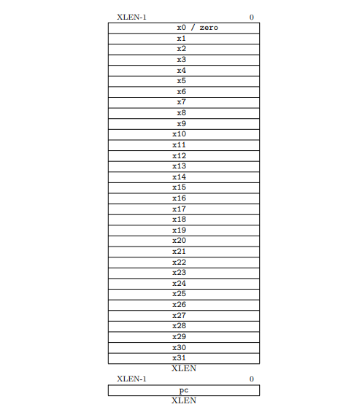.
Figure 1: RISC-V base unprivileged integer register state.
The base RISC-V ISA includes the following types of instructions:
- R-type instructions: These instructions perform arithmetic and logical operations on values in registers. For example, the ADD instruction adds the values in two source registers and stores the result in a destination register.
- I-type instructions: These instructions perform immediate operations, which means that one of the operands is a constant value that is encoded in the instruction itself. For example, the ADDI instruction adds a constant value to the value in a source register and stores the result in a destination register.
- S-type instructions: These instructions store data from a register to memory. For example, the SW instruction stores a word (32 bits) from a source register to a memory location specified by an offset and a base register.
- SB-type instructions: These instructions perform conditional branches. For example, the BEQ instruction branches to a target address if the values in two source registers are equal.
- U-type instructions: These instructions load a 20-bit constant into the upper 20 bits of a register. For example, the LUI instruction loads a 20-bit constant into the upper 20 bits of a destination register and clears the lower 12 bits.
- UJ-type instructions: These instructions perform unconditional jumps. For example, the JAL instruction jumps to a target address and stores the address of the next instruction in a link register.
Computer organization refers to the hardware elements and their connections that implement the architectural standards. It deals with control signals, interfaces, and memory technology. The architectural design defines the operations and principles, while the organizational design focuses on how these functions are implemented in hardware or software.
Combinational elements process data and produce outputs without internal storage, while state elements have storage and require a clock signal for writing data. In RISC-V, the ALU is a combinational element, and general-purpose registers are state elements. Edge-triggered clocking is commonly used, where data is written to state elements on clock signal edges.[1]

2.1.1.1 RV32I Instruction Formats
The fundamental RV32I instruction set architecture (ISA) has four main instruction formats (R, I, S, and U), each 32 bits long and aligned on 4-byte boundaries in memory as shown in Figure 2.1.1.1.1. If the target address of a taken branch or unconditional jump isn't aligned, an exception is raised for that instruction, not the target. Conditional branches that aren't taken don't cause exceptions.

RISC-V simplifies decoding by keeping source (rs1, rs2) and destination (rd) registers in consistent positions across formats. Immediates, except those in CSR instructions, are sign-extended and packed towards the leftmost bits to reduce hardware complexity. The sign bit for all immediates is always in bit 31 for faster sign extension.[2]

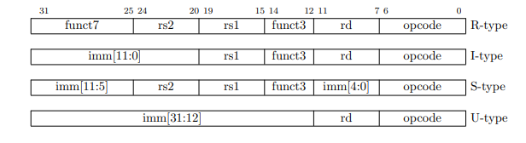
Figure 2: RV32I formats.
Instead of labeling each immediate subfield with its position within the instruction, it's labeled with the bit position in the resulting immediate value. In practice, most immediate are either small or need all 32 bits (XLEN). To maximize opcode space for regular instructions, we chose an uneven split: 12 bits for most immediate and 20 bits for a special load-upper-immediate instruction. We opted for sign-extended immediate to keep the ISA simple, as we didn't see a clear advantage to using zero-extension like in MIPS.[2]

2.1.1.2 RV32I Encoding Variants
In addition to the core instruction formats (R, I, S, and U), RV32I has two more formats (B and J) that handle immediate differently, as shown in Figure 2.1.1.2.1.

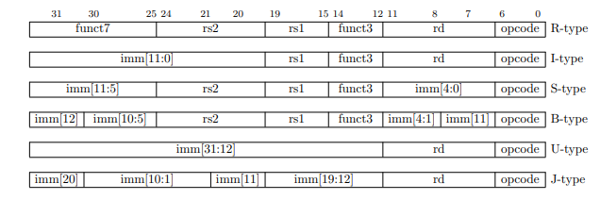
Figure 3: RV32I formats with immediate variants.
The S and B formats are almost identical, except that the B format uses the 12-bit immediate field to encode branch offsets in multiples of 2. Instead of the usual hardware left shift, the middle bits and sign bit stay put, while the lowest bit in S format becomes a high-order bit in B format.
Similarly, the U and J formats differ only in how the 20-bit immediate is shifted: 12 bits left for U immediates and 1 bit left for J immediates. This bit arrangement maximizes overlap between formats.
Figure 2.1.1.2.2 in the reference text illustrates the immediates generated by each base instruction format, showing which instruction bit contributes to each bit of the immediate value.
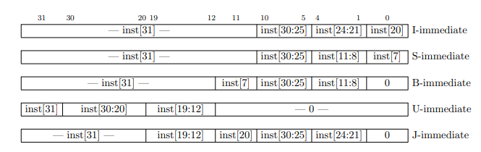
Figure 4: RV32I type of immediate
In RISC-V, the sign bit for immediates is consistently placed in bit 31 of the instruction, enabling sign extension to happen simultaneously with instruction decoding, which is crucial for larger XLEN values (over 32 bits). While complex implementations might have separate adders for branches and jumps, RISC-V prioritizes minimizing hardware costs in simpler designs. By rearranging bits in the instruction encoding of B and J immediates, instead of using hardware to multiply the immediate by 2, the need for extra components is reduced. This bit scrambling doesn't significantly impact static or ahead-of-time compilation, and while there's a minor overhead for dynamic instruction generation, common short forward branches have simple encodings.

2.1.1.3 RV32I Integer Register-Immediate Instructions
The ADDI instruction in RV32I adds a 12-bit immediate value, after sign extension, to the value in register rs1. The result's lower 32 bits are stored in register rd, disregarding any arithmetic overflow. When the immediate is 0, ADDI can be used to move the contents of rs1 to rd (MV pseudoinstruction).
SLTI (set less than immediate) compares the value in register rs1 with a sign-extended 12-bit immediate, treating both as signed numbers. If rs1 is less, it sets register rd to 1, otherwise to 0. SLTIU does the same comparison but treats the values as unsigned. Notably, SLTIU rd, rs1, 1 can be used to check if rs1 is zero (SEQZ pseudoinstruction).
The instructions ANDI, ORI, and XORI perform bitwise AND, OR, and XOR operations, respectively, between the value in register rs1 and a sign-extended 12-bit immediate. The result is stored in rd. XORI rd, rs1, -1 effectively inverts the bits in rs1 (NOT pseudoinstruction).[2]
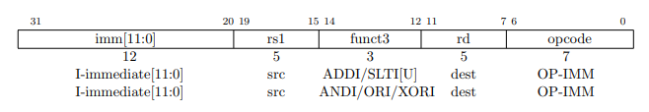
Figure 5: I-type Basic instructions
In RV32I, shifts by a constant value are a specialized form of I-type instructions. The value to be shifted is stored in register rs1, and the shift amount is encoded in the lower 5 bits of the immediate field. Bit 30 determines whether it's a logical right shift (SRLI, with zeros shifted in) or an arithmetic right shift (SRAI, where the sign bit is preserved). SLLI is a logical left shift, filling the lower bits with zeros.

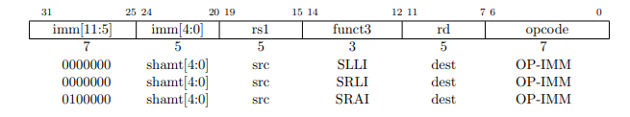
Figure 6: I-type Shift instructions
In the RV32I instruction set, the LUI (load upper immediate) instruction is used to construct 32-bit constants. It takes a 20-bit immediate value and places it in the upper 20 bits of the destination register (rd), filling the lower 12 bits with zeros.
The AUIPC (add upper immediate to PC) instruction is used to create PC-relative addresses. It takes a 20-bit immediate value, appends 12 zeros, and adds the resulting 32-bit offset to the address of the AUIPC instruction itself. The final value is then stored in the destination register (rd).
Together, AUIPC and a subsequent instruction with a 12-bit immediate can access any 32-bit PC-relative address for control transfer (using JALR) or data access (using regular load/store instructions). Setting the U-immediate to 0 in AUIPC allows obtaining the current PC value, which is sometimes preferred over using JAL +4 to avoid potential pipeline disruptions or interference with branch target buffer (BTB) structures in complex microarchitectures.[2]
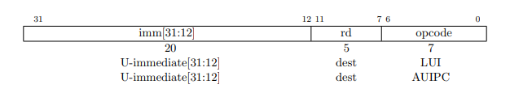

Figure 7: U-type Basic instructions

2.1.1.4 RV32I Integer Register-Register Operations
RV32I offers several R-type instructions for arithmetic operations. Each instruction reads the source operands from registers rs1 and rs2, then writes the outcome to register rd. The specific operation is determined by the funct7 and funct3 fields within the instruction.
ADD and SUB instructions perform addition and subtraction, respectively, discarding any overflow and storing only the lower 32 bits of the result. SLT and SLTU compare the values in rs1 and rs2 as signed and unsigned numbers, respectively. If rs1 is less than rs2, they set rd to 1; otherwise, rd is set to 0. Notably, the SLTU instruction with rd, x0, rs2 can be used to check if rs2 is not zero (SNEZ pseudoinstruction).
Furthermore, AND, OR, and XOR perform bitwise logical operations on the input registers. SLL, SRL, and SRA handle logical left shift, logical right shift, and arithmetic right shift operations, respectively. The shift amount is determined by the lower 5 bits of the value in register rs2.[2]

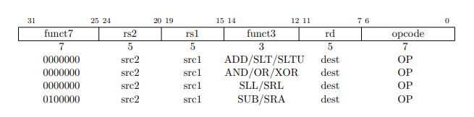
Figure 8: R-type Basic instructions

2.1.1.5 RV32I NOP Instruction
The NOP (no operation) instruction in RV32I doesn't alter the architectural state, except for moving the program counter (PC) forward and potentially updating performance counters. It's encoded as an ADDI instruction with both source and destination registers as x0 and an immediate value of 0.
NOPs are used for aligning code segments to specific address boundaries or reserving space for future code modifications. While there are multiple ways to encode a NOP, a standard encoding is defined to enable microarchitectural optimizations and enhance readability during disassembly. Other NOP encodings are reserved for HINT instructions.
The ADDI instruction was chosen as the basis for NOP because it's likely the most resource-efficient instruction to execute, especially if not optimized out during decoding. It only reads one register, and the hardware for ADDI is often readily available in superscalar designs due to the prevalence of addition operations. This hardware can be shared with address calculation units, unlike register-register ADD or logical/shift operations, which need additional resources.
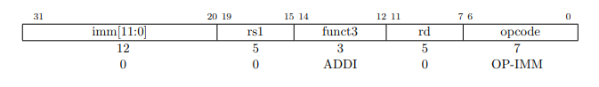
Figure 9: I-type NOP instruction

2.1.1.6 RV32I Unconditional Jumps
The JAL (jump and link) instruction in RV32I uses the J-type format, where the immediate value represents a signed offset in multiples of 2 bytes. This offset is sign-extended and added to the current instruction's address to determine the jump target, enabling jumps within a ±1 MiB range. The address of the instruction following the jump (PC+4) is saved in the destination register (rd). Typically, register x1 is used for the return address, while x5 serves as an optional link register.
This alternate link register (x5) facilitates calling millicode routines, like those used for register saving and restoration in compressed code, without interfering with the primary return address register (x1). Register x5 was chosen because it's usually a temporary register in the standard calling convention, and its encoding differs by just one bit from the regular link register.
Simple unconditional jumps, known as the J pseudoinstruction, are encoded as JAL instructions with the destination register (rd) set to x0.

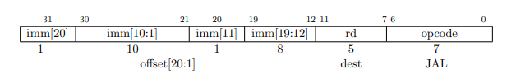
Figure 10: J-type JAL instruction
The indirect jump instruction JALR (jump and link register) uses the I-type encoding. The target address is obtained by adding the sign-extended 12-bit I-immediate to the register rs1, then setting the least-significant bit of the result to zero. The address of the instruction following the jump (pc+4) is written to register rd. Register x0 can be used as the destination if the result is not required.

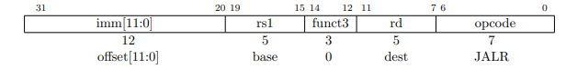
Figure 11: J-type JALR instruction
The RV32I instruction set uses PC-relative addressing for all unconditional jump instructions, facilitating position-independent code. JALR enables jumps within a 32-bit absolute address range by using a two-instruction sequence, either with LUI for the upper 20 bits or AUIPC for a 32-bit PC-relative address. Unlike conditional branches, JALR doesn't treat its 12-bit immediate as a multiple of 2 bytes to simplify hardware, a minor trade-off since it's often used with a zero immediate or paired with LUI/AUIPC. Clearing the least significant bit in the target address calculation simplifies hardware and allows extra information to be stored in function pointers. While this might reduce error checking, incorrect jump addresses usually lead to exceptions quickly. When rs1 is x0, JALR can be used for fast calls to small code sections (2 KiB) anywhere in the address space.
JAL and JALR trigger an exception if the target address isn't 4-byte aligned, unless the machine supports 16-bit aligned instructions like the C extension.
High-performance instruction fetches units often have return-address prediction stacks (RAS), which need to accurately identify call and return instructions. In RISC-V, this is done implicitly through register numbers: JAL pushes to the RAS only when rd is x1/x5, and JALR's behavior depends on the register being used (see Table 2.1 in the reference text). These implicit hinting saves encoding space compared to other ISAs that use explicit hint bits in their jump instructions.

2.1.1.7 RV32I Conditional Branches
In RV32I, all branch instructions use the B-type format, encoding a 12-bit signed offset in multiples of 2 bytes. This offset is sign-extended and added to the branch instruction's address to determine the target, allowing a range of ±4 KiB.
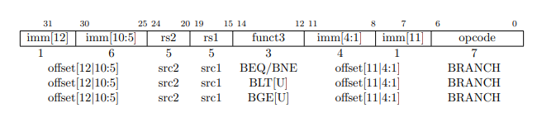
Figure 12: B-type Branch instructions
These instructions compare two registers: BEQ and BNE branch if the values are equal or not, respectively. BLT and BLTU branch if the first register is less than the second, using signed or unsigned comparison. BGE and BGEU branch if the first register is greater than or equal to the second, also with signed or unsigned comparison. Note that BGT, BGTU, BLE, and BLEU can be achieved by swapping the operands of BLT, BLTU, BGE, and BGEU.
A single BLTU instruction can efficiently check signed array bounds, as negative indices will always compare as greater than non-negative bounds.
For optimal performance, software should prioritize the sequential code path, placing less frequent paths out of line. It's assumed backward branches are taken and forward branches aren't, at least initially, with dynamic predictors adapting to branch patterns. Unlike some architectures, RISC-V uses the JAL instruction (with rd=x0) for unconditional branches, as its PC-relative with a wider range than conditional branches and doesn't affect branch prediction.
Conditional branches raise an exception if the target address isn't 4-byte aligned and the condition is true. This exception doesn't occur with 16-bit aligned instruction extensions like the C extension.

2.1.1.8 RV32I Load and Store Instructions
RV32I is a load-store architecture, meaning only load and store instructions access memory, while arithmetic instructions operate solely on registers. It provides a 32-bit byte-addressed address space, with the execution environment (EEI) defining accessible regions and permissions (e.g., read-only or word access). Loads targeting the zero register (x0) must still handle exceptions and side effects, even if the loaded value is discarded. The EEI also specifies endianness (little or big), though RISC-V's endianness is byte-address invariant, ensuring consistent byte order regardless of the address.
In a little-endian system, multibyte stores write the least significant byte to the lowest address, while big-endian systems prioritize the most significant byte. Loads follow the same principle.

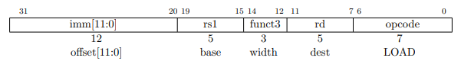
Figure 13: I-type LOAD instruction
Load and store instructions transfer data between registers and memory. Loads use the I-type format, stores use the S-type, and both calculate the effective address by adding a sign-extended 12-bit offset to the base address in register rs1. Loads copy a value from memory to register rd, while stores copy the value from register rs2 to memory.
Specific instructions like LW (load word) load 32 bits, LH (load halfword) loads and sign-extends 16 bits, and LHU (load halfword unsigned) loads and zero-extends 16 bits. LB and LBU handle 8-bit values similarly. SW, SH, and SB store 32-bit, 16-bit, and 8-bit values from rs2, respectively.
Properly aligned loads and stores won't cause misalignment exceptions. However, if the address isn't aligned to the data type's size (4 bytes for 32-bit, 2 bytes for 16-bit), the behavior depends on the EEI. Some EEIs fully support misaligned accesses, handling them in hardware or invisibly. Others might not, potentially raising exceptions or allowing successful but potentially slower execution. If misaligned accesses aren't guaranteed, the EEI must specify whether exceptions are handled by software or lead to termination.
Misaligned access is sometimes needed for legacy code or packed data. Allowing EEIs to choose their support method simplifies adding misaligned hardware support. Alternatives like special instructions or addressing modes were considered less flexible.
Even when successful, misaligned accesses might be slow. Also, while aligned accesses are atomic, misaligned ones might not be, requiring additional synchronization. Atomicity isn't mandatory for misaligned accesses to allow for software handling via traps. If hardware supports misaligned accesses, software can use regular load/store instructions, and the hardware can optimize based on runtime address alignment.

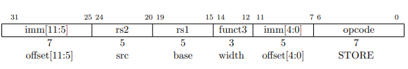
Figure 14: S-type STORE instruction

2.1.2 RV32I Components
The RISC-V data path consists of several interconnected functional blocks:
- Program Counter (PC): A 32-bit register holding the instruction address. It's incremented by 4 in normal operation or updated with a new address for jumps or branches.
- Instruction Memory: A read-only memory storing instruction codes. The PC fetches 32-bit instructions from here.
- Register File: Contains 32 general-purpose registers for data storage. Instructions specify registers for reading or writing data.
- Arithmetic Logic Unit (ALU): Performs arithmetic and logical operations on data from registers or the immediate generation unit.
- ALU Control Unit: Determines the ALU operation based on the instruction and function codes.
- Control Unit: Decodes instructions and generates control signals for the datapath. It also outputs signals to the ALU control unit.
- Data Memory Unit: The system's RAM, storing data in 8-bit registers. It performs read or write operations based on control signals.
- Immediate Generation Unit: Constructs immediate values or addresses from instructions, potentially shifting or sign-extending them.
- Immediate Address Unit: Calculates the correct target address for branch instructions.

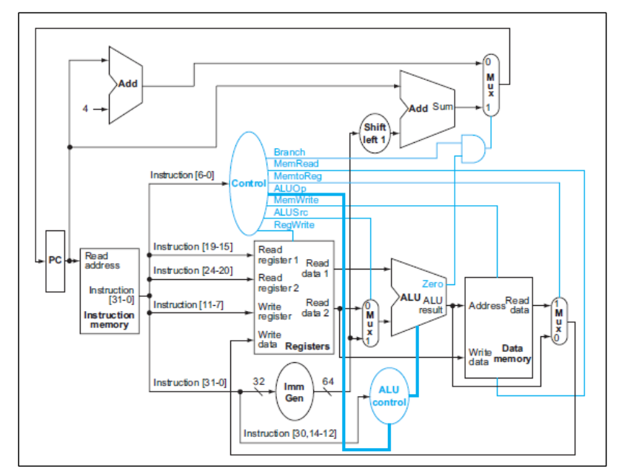
Figure 15: RV32I processor block diagram(Patterson and Hennessy, 2017)
These units work together to execute instructions. The datapath flow varies depending on the instruction type. For example, R-type instructions use register operands, I-type instructions involve immediate values, S-type instructions store data to memory, SB-type instructions are conditional branches, U-type instructions load upper immediate values, and UJ-type instructions are unconditional jumps.

2.1.3 RV32I Pipeline
Pipelining improves processor efficiency by overlapping instruction execution. It divides instruction execution into five stages: Instruction Fetch (IF), Instruction Decode (ID), Execution (EX), Memory Access (MEM), and Writeback (WB). Pipeline registers hold information between stages.
Pipelining in RISC-V is simplified by fixed instruction length and format, along with the simplicity of base instructions. However, it introduces hazards:
- Structural Hazards: Multiple instructions trying to access the same hardware simultaneously. Solved by using separate memories for instructions and data (Harvard Architecture).
- Data Hazards: Data dependencies between instructions. Solved by forwarding data from later stages or stalling the pipeline.
- Control Hazards: Uncertainty about which instructions to fetch after branches or jumps. Solved by stalling, branch prediction, or moving branch comparison earlier in the pipeline.
Data forwarding passes results from later stages to earlier stages to resolve data hazards. It involves checking register addresses and forwarding data when needed. Pipeline stalling is used when data is not yet available, like in load-use hazards.
Pipeline flushing removes invalid instructions from the pipeline when a branch is taken. It's triggered by control signals and the zero flag from the ALU. Branch prediction can be used to avoid stalling in most cases.

2.2 Universal Verification Methodology
UVM's testbench development approach is layered and object-oriented, allowing for "separation of concerns" among team members. UVM testbench components serve specialized purposes and provide clear interfaces for increased productivity and reuse. Assembling these components into a testbench creates a modular and reusable verification environment. This allows test writers to focus on transactional functionality while the testbench architect focuses on how the test interacts with the DUT.

2.2.1 UVM Testbench Architecture
UVM includes required class libraries for creating dynamic and reusable verification environments. These libraries contain utilities such as configuration databases, transaction models, and component hierarchies. They speed up the construction of structured verification components and test environments. In a typical UVM configuration, verification environments are built with predefined UVM classes that provide standardized communication architecture. This infrastructure allows verification components to communicate data packets in synchrony. Here's an example of a typical testbench architecture.

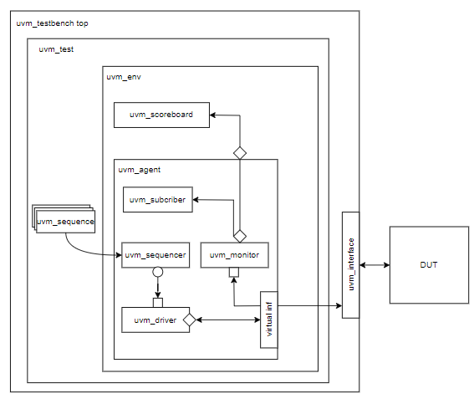
Figure 16: UVM Testbench Architecture
This architecture demonstrates how multiple UVM components interact within the testbench, allowing for effective communication and collaboration throughout verification procedures.
In a UVM testbench, components generated from the uvm_component base class build a stable hierarchy that remains consistent throughout the simulation. These components include long-term entities including environments, agents, monitors, drivers, and scoreboards. They control the testbench's general structure and behavior, including configuration, stimulus production, data validation, and reporting.
In contrast, sequence objects (uvm_sequence, uvm_sequence_item, and so on) are temporary. They are dynamically generated to define specific test sequences, executed during the simulation, and then destroyed after their task is completed. Sequences contain test scenarios, such as transaction sequences and synchronization points, and communicate with the DUT via uvm_sequencer and uvm_driver objects.
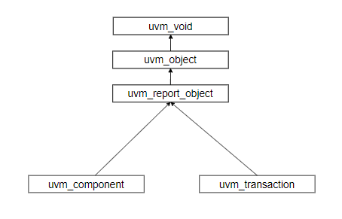
Figure 17: UVM hierarchy
This contrast between persistent uvm_component objects and transient sequence objects enables testbench design that is both flexible and economical, providing clear responsibilities and appropriate simulation resource management.

2.2.2 UVM Component Class
UVM components are units which are building blocks of the total hierarchical verification environment for UVM. The components which the verification components that process UVM objects and pass the transactional data from one component to the next. The parent-child relationship of the components also supports configuring each component for use as a feature or different test cases. In this section, all its components of the UVM component class will be explained.

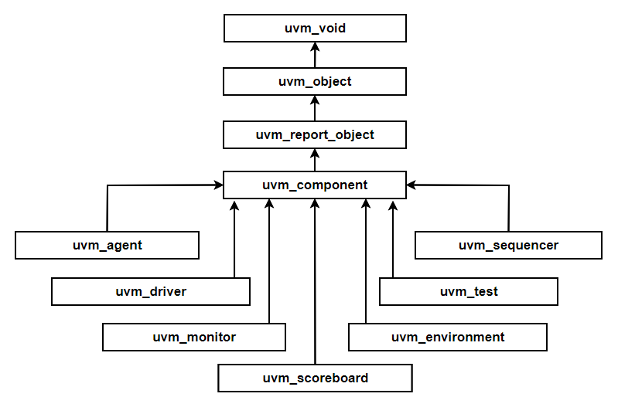
Figure 18: UVM component hierarchy

In UVM hierarchy:
- uvm_object: This class is the foundation for all objects in a computer language. It includes fundamental techniques for tasks including creation, destruction, and accessing properties and methods.
- uvm_report_object: This class generates reports on the state of objects in the program.
- uvm_component class describes a system component. It can hold other objects and communicate with other components.
- uvm_agent: This class denotes an agent in the system. It can take actions on other components.
- uvm_driver: This class controls hardware devices.
- uvm_monitor: This class monitors the state of hardware devices.
- uvm_test: This class describes a test case. It may contain agents, drivers, and monitors.
- uvm_environment: This class refers to the simulation environment. It may contain components, agents, drivers, and screens.
- uvm_scoreboard: This class monitors the progress of test cases.

2.2.2.1 UVM testbench top
The UVM testbench top connects the UVM components and ensures that all UVM components (agent, driver, monitor, sequencer, scoreboard) collaborate to execute DUT testing. Below is the connection location of uvm testbench top in uvm basic diagram:

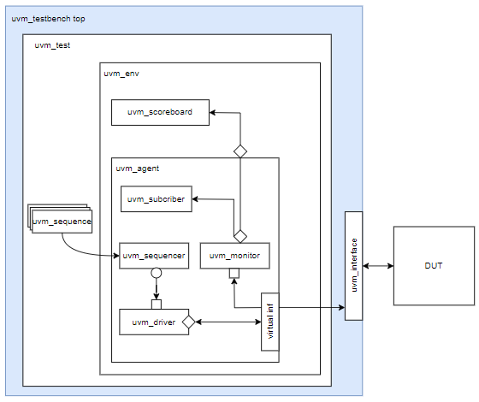
Figure 19: UVM testbench top in UVM
A typical UVM testbench top is the root node, often known as the top-level module. It serves as a static container for all verification components, interfaces, and the design being tested. It is in charge of initiating the test on the design.
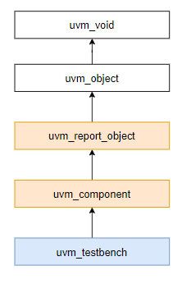
Figure 20: UVM testbench top hierarchy
The top hierarchy of the UVM testbench is tb_top_uvm.sv. This module performs the following operations:
- Clock generation.
- Reset de-assertion.
- Interfaces assignments.
- Wrapper instantiation.
- Test run.
The first two actions define the system clock and de-assert the rst_n after a set number of cycles.
Interface assignments establish the connection between the DUT and UVM interfaces. To use the UVM framework, all essential signals must be written hierarchically in interface declarations. Using this strategy, any UVM component connected to the interfaces can capture signals from the device being verified.
After the Wrapper is instantiated, the UVM test is launched via run_test().
The UVM Testbench creates the Design under Test (DUT) module and UVM Test class, then configures their connections. Verification collaterals with module-based components are also tested using the UVM Testbench. The UVM Testbench may execute several tests by dynamically instantiating them at runtime.
In some systems, the word "Testbench" refers to a module that contains verification collaterals and integrates with the DUT.

2.2.2.2 UVM test
Below is the connection location of uvm test in uvm basic diagram:

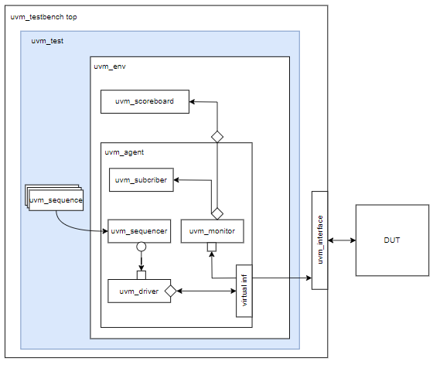
Figure 21: UVM test in UVM
The test component is the component hierarchy's highest degree of verification. This component creates and configures the environment component, which is the next level down in the hierarchy. It initiates stimulus generation using virtual sequences. A test case specifies the stimuli and conditions for a verification test, testing certain design aspects under defined conditions. Configuring the environment allows the test component to generate several test cases, demonstrating reusability in the verification environment.

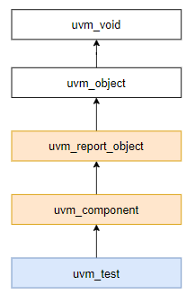
Figure 22: UVM test hierarchy
The test contains environment classes, setups, and start sequences for sequencers. To avoid repeating the same code in each test, it is advisable to have a basic test that includes all testbench settings, including an instance of the environment class, generate configurations, and so on, and that can be expanded from the base test to build various tests as per the verification test plan. The derived tests can additionally configure settings based on test requirements.

2.2.2.3 UVM environment
Below figure is the connection location of uvm environment in uvm basic diagram:

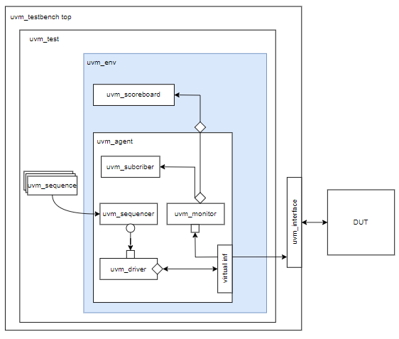
Figure 23: UVM env in UVM
The environment component groups and instantiates connected verification components, including the agent, scoreboard, and others. The test component sets several configuration options to tailor the environment to different test scenarios.
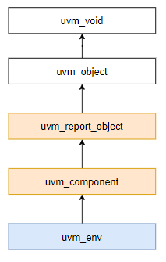
Figure 24: UVM env hierarchy
“uvm env” is the basic class for hierarchical containers of other components that comprise an entire environment. It can be utilized as a sub-component in a bigger environment or as a standalone verification environment that can be invoked directly in a variety of tests.

2.2.2.4 UVM agent
The UVM agent generates the stimulus signals to send to the DUT. Below figure is the connection location of uvm agent in uvm basic diagram:

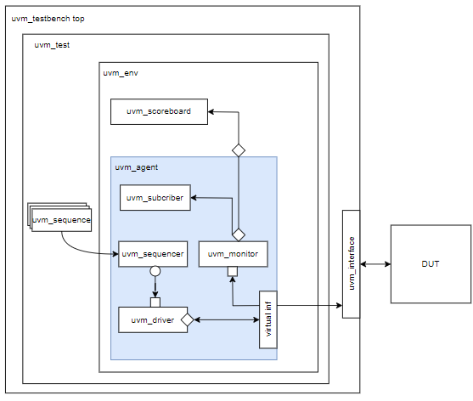
Figure 25: UVM agent in UVM
The uvm agent combines a sequencer, driver, and monitor into a single entity by instantiating and linking the components through TLM interfaces. As UVM is all about configurability, an agent can also contain configuration options like the type of UVM agent (active/passive), knobs to turn on features such as functional coverage, and other similar parameters.

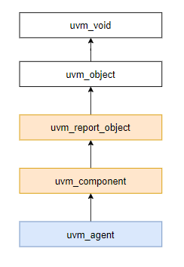
Figure 26: UVM agent hierarchy
The agent component is a hierarchical component that contains verification components related to a certain design under test interface. The components comprise a sequencer, driver, and monitor. Transaction-level modeling interfaces enable the instantiation and interconnection of verification components. The agent component, like the environment component, includes configuration choices for enabling or disabling functionality, as well as selecting active or passive monitoring.

2.2.2.5 UVM driver
The UVM driver translates the agent's stimulus signals into a format that can be communicated with the DUT. Below figure is the connection location of uvm driver in uvm basic diagram:

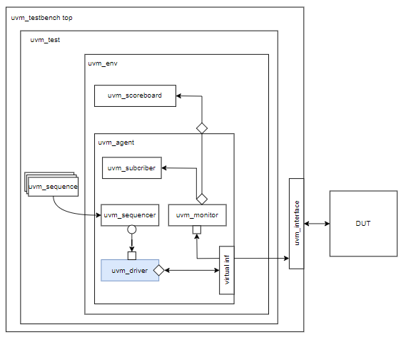
Figure 27: UVM driver in UVM

The UVM driver communicates with the sequence via TLM and converts between sequence_item on the transaction side and pin-level activity when connecting with the DUT through a virtual interface. Drivers receive a sequence_item and use it to send signals to the DUT. In some cases, they may also receive a pin-level response from the DUT and convert it into a sequence_item to complete the transaction. A driver can operate as a "responder" by responding to pin-level activity in the interface and communicating with a sequence. The sequence then sends a response transaction to the driver to finish the protocol transaction.
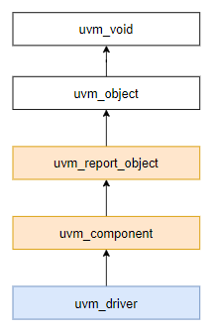
Figure 28: UVM driver hierarchy
The driver communicates with the DUT. It sends randomized transactions or sequence items to DUT as a pin-level activity through an interface. The driver must be extended from uvm_component names to uvm_driver. The sequencer retrieves the transaction or sequence items, which are then driven to the design by the driver via the interface handle. An interface handle can be obtained from the configuration database, which was previously set in the top-level hierarchy.

2.2.2.6 UVM monitor
The UVM is a component that accepts data from the DUT (often via a monitor port) and compares it to the predicted results. Below figure is the connection location of uvm monitor in uvm basic diagram:
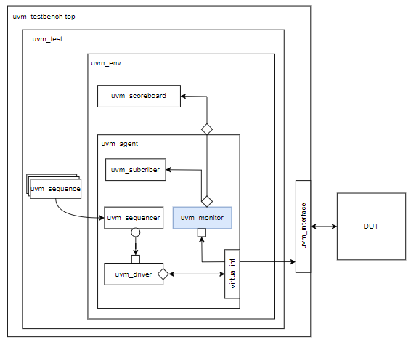
Figure 29: UVM monitor in UVM
A UVM monitor is a passive component that captures DUT signals through a virtual interface and converts them into sequence item format. These sequence items or transactions are sent to other components, such as the UVM scoreboard and coverage collector. It broadcasts transactions using a TLM analysis port.
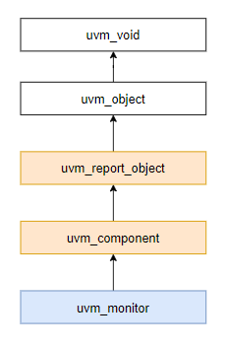
Figure 30: UVM monitor hierarchy
The UVM monitor functionality should be limited to basic monitoring that is always required.It may have knobs to enable/disable basic protocol checking and coverage collection. High level functional checking should be done outside the monitor, in a scoreboard.

2.2.2.7 UVM scoreboard
The UVM scoreboard is a component that tests the functionality of the DUT. It receives transactions from the monitor via the analysis export and checks them. Below figure is the connection location of uvm scoreboard in uvm basic diagram:

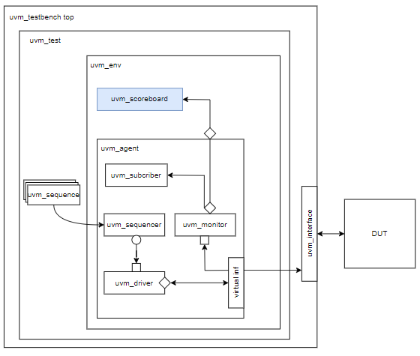
Figure 31: UVM scoreboard in UVM
The UVM Scoreboard typically receives transactions containing DUT inputs and outputs via UVM Agent analysis ports, runs the input transactions through a reference model (also known as the predictor) to generate expected transactions, and then compares the expected output to the actual output. There are several approaches for implementing the scoreboard, the nature of the reference model, and communicating with the rest of the testbench.
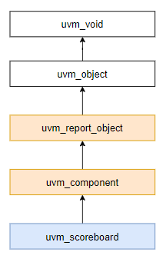
Figure 32: UVM scoreboard hierarchy

2.2.3 UVM Transaction Base Class
A “uvm_transaction” defines data objects ingested and operated on by verification components.

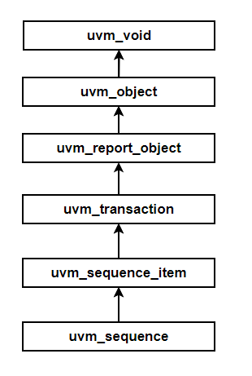
Figure 33: UVM transaction hierarchy

2.2.3.1 UVM sequence item
The UVM stimulus production procedure involves generating sequence_items and transmitting them to drivers via a sequencer. The stimulus generation flow relies on the sequence structure for control, while the generation data flow uses sequence_items as data objects.
Sequence_items must be carefully designed because they serve as the foundation upon which sequences are created. Sequence_item content is based on the information required by the driver to execute pin-level transactions, the ease of generating new data objects using limited random generation, and analysis hooks.
The uvm_sequence_item is derived from the uvm_object through the uvm_transaction class. Implementing the uvm_object's virtual methods, such as copy, clone, compare, print, and transaction recording, can make the sequence_item more flexible.
Sequence_items are commonly used in analysis traffic and can benefit from utility functions to improve functional coverage and analysis.

2.2.3.1 UVM sequence
The uvm_sequence derives from the uvm_sequence_item, which in turn is derived from the uvm_object. Both basic classes are called objects rather than components. The UVM testbench component hierarchy is made up of uvm_components, each with unique attributes. These components are connected into a static hierarchy that remains in place during the simulation.
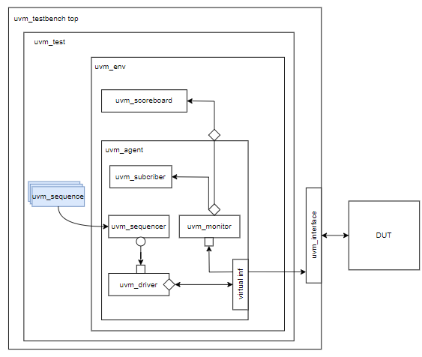
Figure 34: UVM sequence in UVM

A UVM sequence includes a job known as body. To use a sequence, first build it, then execute the body method, and finally trash it. Sequences, unlike uvm_components, have a limited simulation life-time, making them fleeting objects. The sequence body method can be used to execute sequences, generate sequence_item objects, and send them to a driver component for pin-level activity. It can also combine the two.

2.2.4 UVM phase
To ensure consistent testbench execution, the UVM organizes major steps during simulation into phases. There are three groups of phases, which are carried out in the following order:
- Build phases, where the testbench is configured and built.
- Run-time phases - where time is consumed in running the testcase on the testbed
- Clean-up phases, in which the testcase results are collected and reported.
The following figure depicts the various phase groupings. The uvm_component base class has virtual methods that are called by phase methods. The testbench component creator populates these methods based on the component's participation in each phase. Using specified phases enables verification components to be designed separately while remaining interoperable due to a shared understanding of each phase's requirements.

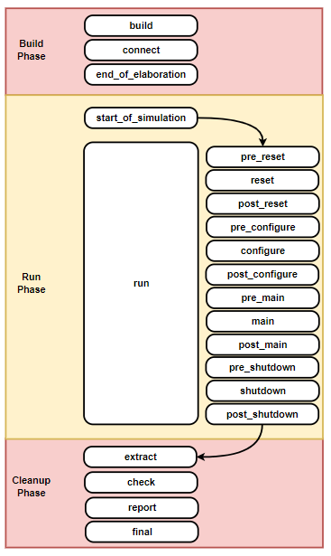

Figure 35: UVM phase step

CHAPTER 3. IMPLEMENTATION

3.1 RV32I Implementation

3.1.1 The Program Counter module
The program counter (PC) in the RV32I architecture is a 32-bit register that stores the memory address of the next instruction to be fetched and executed. In normal operation, the PC increments by 4 to fetch the next sequential instruction. However, for control transfer instructions like jumps and branches, the PC is updated with the target address, allowing the processor to deviate from the sequential flow.
The PC's operation is closely linked to the instruction fetch stage of the pipeline. It provides the address to the instruction memory, from which the corresponding instruction is fetched. For branch instructions, the PC's value is determined by the outcome of the branch condition evaluation in the execute stage. If the branch is taken, the PC is updated with the branch target address; otherwise, it is incremented by 4.
The control unit manages the PC's update process, selecting the appropriate next address based on various control signals. These signals include those for unconditional jumps, taken branches, system resets, returns from interrupts and traps, and other scenarios.
Essentially, the PC acts as a guide for the processor, directing it through the instruction sequence and ensuring the correct execution flow of the program. Its ability to be modified by control flow instructions like branches and jumps enables the implementation of complex program logic.
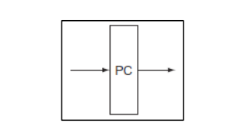
Figure 36: RV32I Program Counter block diagram (Patterson and Hennessy, 2017)

3.1.2 The Instruction Memory module

The instruction memory in the RV32I architecture is a read-only memory (ROM) that stores the binary-encoded instructions of a program. It is byte-addressable, meaning each byte has a unique address. Since RV32I instructions are 32 bits (4 bytes) long, fetching a single instruction requires accessing four consecutive memory locations.
The instruction memory operates by receiving an address from the program counter (PC), which indicates the location of the first byte of the instruction to be fetched. The memory then reads the four bytes starting at that address and combines them to form the 32-bit instruction. This instruction is then sent to the instruction decoder for further processing.
The instruction memory is a fundamental component of the RV32I architecture, as it supplies the instructions that the processor executes. The size and organization of the instruction memory can vary depending on the specific implementation of the RISC-V processor.

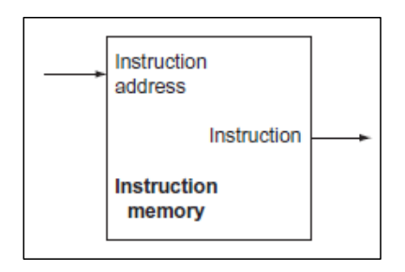
Figure 37: RV32I Instruction Memory block diagram(Patterson and Hennessy, 2017)

3.1.3 The Register File module
The register file in the RV32I architecture is a set of 32 general-purpose registers, each 32 bits wide. These registers serve as fast on-chip storage for data that instructions can directly operate on. This contrasts with load-store architectures, where arithmetic instructions can only work with data in registers, not directly from memory.
The register file supports both reading and writing data. During instruction execution, one or two registers are read to provide operands for the arithmetic logic unit (ALU). Results from ALU operations are then written back to the destination register, usually on the rising edge of the clock signal.
This register file is crucial for efficient instruction execution due to its fast access to frequently used data. The RISC-V ISA doesn't impose strict rules on most register usage, offering flexibility in software design. However, some registers like x0 (always zero) and x1 (return address) have specific roles in the standard calling convention.
The number of registers impacts code size, performance, and energy use. While 16 registers might suffice for some integer ISAs, RV32I has 32 to enable efficient instruction encoding and boost performance in demanding scenarios.
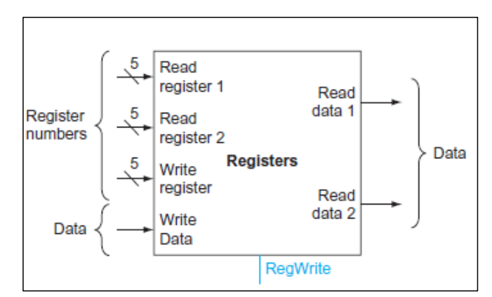
Figure 38: RV32I Instruction Memory block diagram(Patterson and Hennessy, 2017)

3.1.4 The Arithmetic Logic Unit module
The Arithmetic Logic Unit (ALU) in the RV32I architecture is a core component that carries out arithmetic and logical operations on data. It takes two 32-bit inputs and produces a 32-bit result, determined by the ALU control signal. This signal is generated by the ALU control unit, which decodes the instruction and sets the appropriate ALU control signal value based on the opcode and function codes.
The ALU supports a wide range of operations, including addition, subtraction, multiplication, division, bitwise operations (AND, OR, XOR, NOT), and shifts (logical left, logical right, arithmetic right). It also handles comparison operations like less than, greater than, and equal to.
Besides the result, the ALU also produces a "zero" signal, indicating whether the result is zero. This signal is used by the control unit to determine branch outcomes.
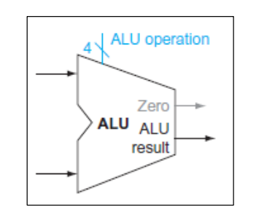
Figure 39: RV32I Instruction Memory block diagram (Patterson and Hennessy, 2017)

3.1.5 The ALU Control module
The ALU control unit in RV32I is responsible for determining the specific operation that the Arithmetic Logic Unit (ALU) should perform. It does this by decoding the instruction's opcode and function codes, then generating the appropriate control signal to direct the ALU's behavior.
The ALU control unit's operation is closely tied to the instruction decode (ID) stage of the pipeline. Once an instruction is fetched and decoded, the ALU control unit analyzes the opcode and function codes to identify the intended operation. Based on this analysis, it generates the ALU control signal, which is a set of bits that control the ALU's internal circuitry.
The ALU control signal acts as a selector, determining which operation the ALU will execute. For example, different values of ALU control signal might correspond to addition, subtraction, logical operations (AND, OR, XOR), or various types of shifts. The ALU control unit ensures that the correct ALU control value is generated for each instruction, allowing the ALU to perform the intended operation on the data. In essence, the ALU control unit acts as a translator, converting the instruction's opcode and function codes into a specific control signal that the ALU can understand and act upon. This ensures that the ALU performs the correct operation for each instruction, contributing to the overall functionality and accuracy of the RV32I processor.
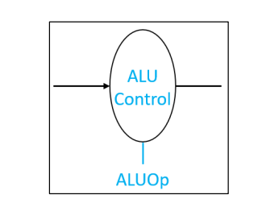

Figure 40: RV32I Instruction Memory block diagram (Patterson and Hennessy, 2017)

3.1.6 The Control Unit module
The control unit in the RV32I architecture is a crucial component responsible for orchestrating the execution of instructions. It decodes instructions, generates control signals, and manages the overall operation of the processor.

The primary function of the control unit is to interpret the instructions fetched from memory and generate the necessary control signals to coordinate the activities of other components within the processor. These control signals govern the flow of data, the selection of operands, the operation of the ALU, and the writing back of results.

It ensure these processes operate:
- Instruction Fetch (IF): The control unit receives the instruction from the instruction memory.
- Instruction Decode (ID): The control unit decodes the instruction, identifying the opcode (operation code) and the operands involved.
- Control Signal Generation: Based on the decoded instruction, the control unit generates a set of control signals. These signals are sent to various components of the processor, such as the ALU, register file, and data memory, to initiate and control their operations.
- Execution (EX): The control unit oversees the execution of the instruction, ensuring that the correct operands are fetched from the register file, the ALU performs the appropriate operation, and the results are stored back in the register file or memory.
- Write Back (WB): The control unit manages the writing back of the results to the register file or memory.
The control unit also handles exceptions and interrupts, ensuring that the processor responds appropriately to these events. It might involve saving the current state of the processor, jumping to an interrupt handler routine, and restoring the state after the interrupt is handled.
In essence, the control unit acts as the "brain" of the RV32I processor, interpreting instructions and directing the actions of other components to ensure the correct and efficient execution of programs.

3.1.7 The Data Memory module
The data memory in the RV32I architecture serves as the system's RAM (Random Access Memory). It's where the program's data is stored, and it's byte-addressable, meaning each byte has a unique address.
The data memory is accessed using load and store instructions. These instructions use a base address (stored in register rs1) and a 12-bit signed offset to calculate the effective address of the data to be accessed.
- Load instructions copy data from the specified memory address into a register (rd).
- Store instructions copy data from a register (rs2) to the specified memory address.
The data memory supports different access sizes:
- Load Word: Loads a 32-bit word from memory.
- Load Halfword: Loads a 16-bit halfword and sign-extends it to 32 bits.
- Load Halfword Unsigned: Loads a 16-bit halfword and zero-extends it to 32 bits.
- Load Byte: Loads an 8-bit byte and sign-extends it to 32 bits.
- Load Byte Unsigned: Loads an 8-bit byte and zero-extends it to 32 bits.
- Store Word: Stores a 32-bit word to memory.
- Store Halfword: Stores a 16-bit halfword to memory.
- Store Byte: Stores an 8-bit byte to memory.
The behavior of misaligned accesses (where the address isn't a multiple of the data size) depends on the execution environment (EEI). Some EEIs might handle them seamlessly, while others might raise exceptions.
The data memory is a crucial part of the RV32I architecture, enabling the processor to interact with data stored in memory. Its flexibility in accessing different data sizes and its interaction with the execution environment make it adaptable to various applications.
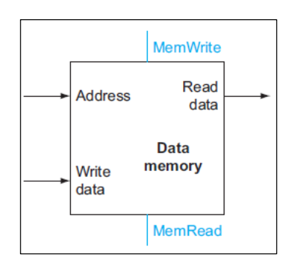

Figure 41: RV32I Data Memory block diagram (Patterson and Hennessy, 2017)

3.1.8 The Immediate Generation module
The immediate generation unit in the RV32I architecture is responsible for constructing immediate values or addresses from the instruction code. These immediate values can be used as operands in arithmetic and logical instructions, or as offsets in load and store instructions. The immediate generation unit may also perform sign extension or zero extension on the immediate value, depending on the instruction.
The immediate generation unit is a combinational circuit, meaning that its output is determined solely by its inputs. The inputs to the immediate generation unit are the instruction code and the current program counter (PC) value. The output of the immediate generation unit is the immediate value or address.
The specific operation performed by the immediate generation unit depends on the type of instruction. For example, for an I-type instruction, the immediate generation unit will sign-extend the 12-bit immediate field in the instruction code. For a U-type instruction, the immediate generation unit will zero-extend the 20-bit immediate field in the instruction code. For a J-type instruction, the immediate generation unit will sign-extend the 20-bit immediate field in the instruction code and then add it to the PC value.
The immediate generation unit is a critical component of the RV32I architecture, as it allows instructions to operate on immediate values or addresses. This can significantly improve the performance of the processor, as it avoids the need to load the immediate value or address from memory.
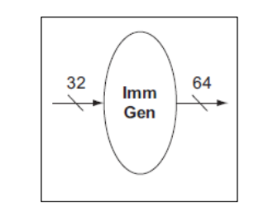
Figure 42: RV32I Immediate Generation block diagram(Patterson and Hennessy, 2017)

3.1.9 The Immediate Address module
In the RV32I instruction set architecture, the immediate address unit is responsible for calculating the target address for jump instructions. It takes the current instruction address (PC) and adds a sign-extended immediate value encoded in the instruction to determine the jump target. This allows for jumps within a specific range relative to the current PC.
The immediate value is not treated as a multiple of 2 bytes, unlike in conditional branch instructions. This design choice simplifies the hardware implementation by avoiding the need for an additional immediate format. In most cases, the immediate value used with JALR is either zero or paired with LUI or AUIPC instructions, so the slight reduction in range is not a significant drawback.

3.1.10 RV32I Pipeline
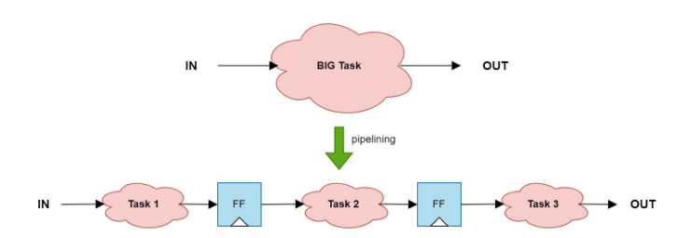
Figure 43: Pipelining breaks the critical path segregating the combo logic and adding registers in between classic RISC-V stages

Pipelining is a technique used to enhance the efficiency and throughput of a processor's data flow by overlapping the execution of instructions. The concept is to slit a big path into smaller path as shown in Figure 43. In a pipelined CPU, instruction execution is divided into five stages:
1. Instruction Fetch (IF): Instructions are fetched from memory.
2. Instruction Decode (ID): Registers are read, and the instruction is decoded. Control signals are generated to manage the hardware, and immediate values or offsets are calculated if needed.
3. Execution or Address Calculation (EX): The operation specified by the instruction is executed, or the target address is calculated based on the control signals.
4. Data Memory Access (MEM): If required, an operand is read from or written to the data memory.
5. Write Back (WB): The result of the operation is written back to a register, if necessary.
This pipelined approach allows multiple instructions to be in different stages of execution simultaneously, increasing throughput as shown in Figure 44. However, it can introduce hazards like data hazards (dependencies between instructions) or control hazards (due to branches).

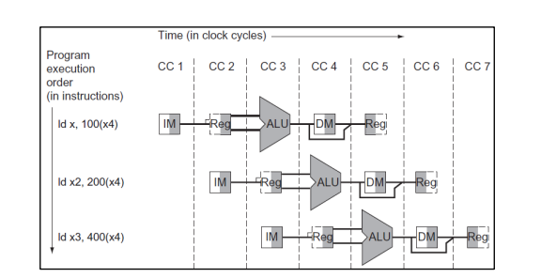
Figure 44: Multiple Instructions executed with Pipeline Implementation
In the RV32I architecture, the pipeline typically consists of four stages: Instruction Fetch (IF), Instruction Decode (ID), Execute (EX), and Writeback (WB). The memory access stage is likely combined with the write-back stage in this implementation.
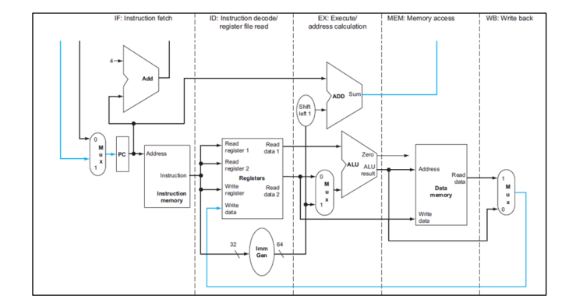
Figure 45: the concept of separating the datapath flow into several stages
Pipeline registers are used to store information processed at each stage of the pipeline, allowing for the efficient transfer of data between stages and the concurrent execution of multiple instructions. Each pipeline register is named after the two stages it separates, for example, the IF/ID pipeline register sits between the Instruction Fetch (IF) and Instruction Decode (ID) stages.
Control signals, decoded by the control unit in the ID stage, are needed throughout the execution of an instruction. Therefore, these signals are passed down the pipeline registers along with the instruction itself, ensuring that the correct hardware control signals are available at each stage for the specific instruction being processed.
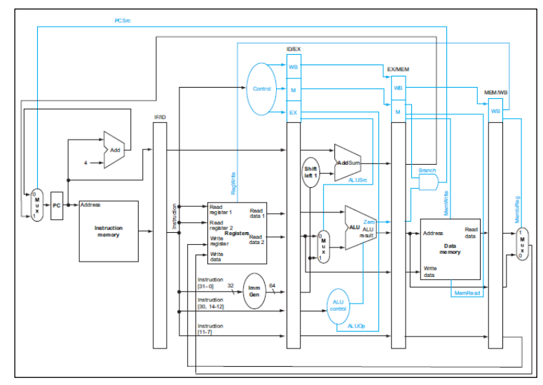
Figure 46: Pipelined Datapath with Control Elements integrated
Pipelining in RISC-V is simplified by fixed instruction length and format, along with the simplicity of base instructions. However, it introduces hazards:
- Structural Hazards: Multiple instructions trying to access the same hardware simultaneously. Solved by using separate memories for instructions and data (Harvard Architecture).
- Data Hazards: Data dependencies between instructions. Solved by forwarding data from later stages or stalling the pipeline.
- Control Hazards: Uncertainty about which instructions to fetch after branches or jumps. Solved by stalling, branch prediction, or moving branch comparison earlier in the pipeline.
Data forwarding passes results from later stages to earlier stages to resolve data hazards. It involves checking register addresses and forwarding data when needed. Pipeline stalling is used when data is not yet available, like in load-use hazards.
Pipeline flushing removes invalid instructions from the pipeline when a branch is taken. It's triggered by control signals and the zero flag from the ALU. Branch prediction can be used to avoid stalling in most cases.

3.2 RV32I Verification

3.2.1 Verification plan
The RV32I testbench design can aid in the development of a reusable testbench architecture that supports a wide range of functional verification scenarios and procedures. Configurability for testbench components enables the implementation of a variety of functional verification approaches, including constrained random verification and directed verification, on the same testbed. The RV32I RTL design architecture is tested by the functional testing reference model. The improved UVM implementation enables synchronous operation between the reference model and the design being tested. The synchronous operation enables the UVM monitoring component to collect synchronized output and forward it to the UVM scoreboard component for analysis and comparison result output data.
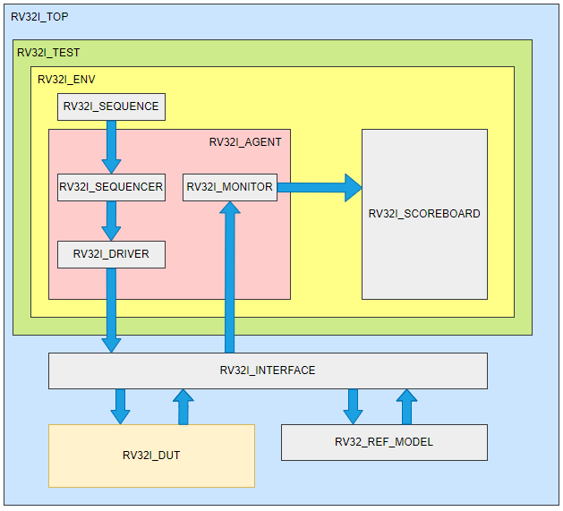
Figure 47: RV32I UVM Testbench Architecture
The UVM testbench is divided into several hierarchical components, each with a distinct purpose in the verification process. The components are listed below:
- rv32i_top: the top-level module of the uvm testbench.
- rv32i_test: encapsulates the overall test, including the environment.
- rv32i_env: the environment containing the agent, scoreboard, and the interface to the dut and reference model.
- rv32i_agent: comprises the sequencer, driver, and monitor.
- rv32i_interface: the connection point between the testbench components and the dut.
- rv32i_dut: the device under test, which in this case is the rv32i rtl design.
- rv32i_ref_model: a reference model for comparing expected behavior with actual dut behavior.
- rv32i_scoreboard: collects and compares the actual output of the dut to the expected output from the reference model.

3.2.2 Testbench implementation

3.2.2.1. Testbench flow
The flowchart depicts a systematic method for validating the RV32I DUT with UVM.

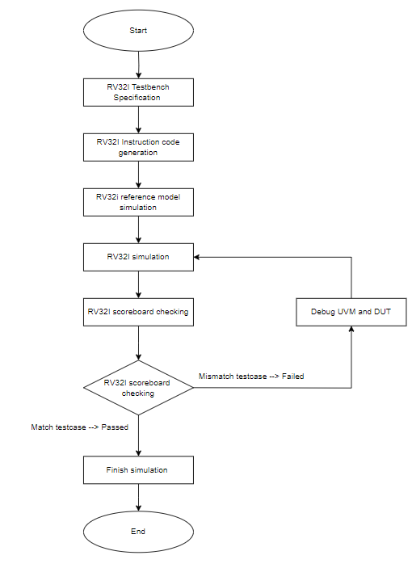
Figure 48: UVM flow chart
Flowchart Steps Analysis
- Start: Begin the verification procedure.
- RV32I Testbench Specification: Specify the testbench criteria and scenarios.
- RV32I Instruction Code Generation: Generate instruction sequences for testing.
- RV32I Reference Model Simulation: Execute instructions on a reference model to achieve the intended outcomes.
- RV32I Simulation: Follow the generated instructions to simulate the DUT.
- RV32I Scoreboard Checking: Compare the DUT output to the predicted results from the reference model.
- RV32I Scoreboard Inspection Decision:
  - Match Test Case --> Passed: If the results match, the test case succeeds.
  - Mismatch Testcase --> Failed: If the outputs do not match, proceed with debugging.
- Debug UVM and DUT: Identify and address problems with the testbench or DUT.
- Finish Simulation: Complete the simulation process.
- End: Complete the verification process.
It emphasizes the significance of creating thorough test cases, simulating both the DUT and the reference model, and comparing the results to verify accuracy. The addition of a debug phase guarantees that any differences are addressed, resulting in a rigorous verification procedure. This flow presents a clear and systematic way for thoroughly and effectively verifying the RV32I.

3.2.2.3. Test scenario

3.2.2.3.1 Directed testcase
Directed testcases in UVM are designed to test specific functions or scenarios of the RV32I DUT. Fixed testcases will load a running scenario into the RV32I UVM with predefined settings and instructions.
Objectives of Directed testcases:
- Test certain RV32I DUT functionality.
- Verify edge cases or special cases that may not be easily accomplished through random generation.
- Ensure that the RV32I DUT performs properly in predefined scenarios.
The code segment below shows how the file is accessed and compared to a defined list of instructions. When an instruction operation is correctly matched, it assigns values to the opcode, funct3, and funct7 fields and defines the instruction type for encoding and operand processing.
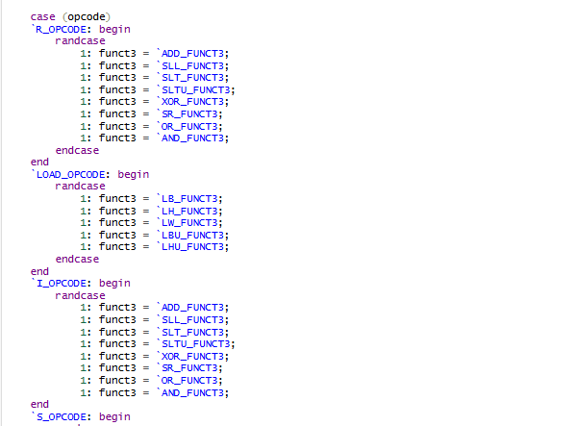
Figure 49: Code of uvm sequence item

3.2.2.3.2 Randomized testcase
Randomized testcases play a vital role in the UVM environment's RV32I processor testing and verification. It improves test coverage, detects potential errors, and ensures that the DUT works properly in a range of situations.
Objectives of Randomized testcases:
- Increase test coverage: Randomized test cases help to generate a range of test scenarios, enhancing the DUT's test coverage.
- Using random values can discover flaws that specific test cases may not uncover.
- Randomized test cases are used to assess the DUT's performance and dependability in a variety of scenarios.
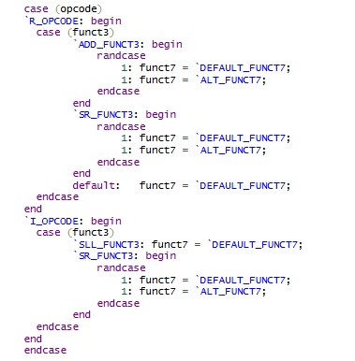
Figure 50: Code random test in uvm sequence item

3.2.2.3.3 ASM simulation testcase
The ASM simulation testcase is an essential component of testing and validating the RV32I processor in the UVM environment. It helps to verify that the processor correctly executes Assembly instructions and performs in predetermined scenarios. Using an ASM simulation testcase improves the reliability and precision of the final product.
Objectives of ASM Simulation Testcase
ASM (Assembly) simulation testcases use assembly code to test and validate RV32I operation. The primary objectives include:
- When assembled instructions are performed on the processor, they are tested for accuracy.
- Check sure the processor carries out the instructions as intended.
- Ensure that the instructions are followed correctly in specific circumstances.

3.2.3 RV32I UVM component implementation
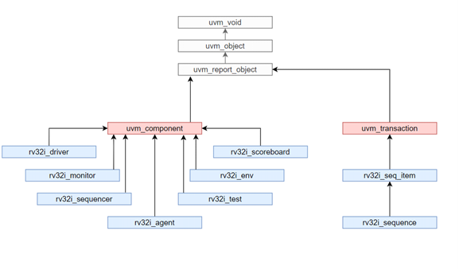
Figure 51: RV32I UVM hierarchy

3.2.3.1 RV32I sequence
The RV32I sequence is a set of instructions used to test and verify the operation of a processor based on the RISC-V RV32I architecture. RV32I sequence is typically implemented in the UVM environment as a subclass of uvm_sequence, inheriting from uvm_sequence and using rv32i_seq_item as sequence elements.
RV32I sequence is one that is used to test and simulate the execution of instructions and programs that use the RISC-V RV32I instruction set. This sequence could include activities such as:
- RV32I instructions can be generated and executed at random or sequentially.
- Test processor features such as register reads and writes, ALU calculations, and memory accesses.
- Analyzing the results to ensure that the RV32I instructions were executed correctly and accurately.
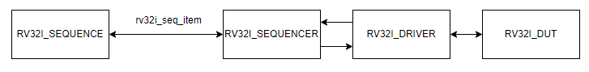
Figure 52: Sequence flow
The rv32i sequence architecture uses sequences to generate stimuli and communicate sequence_items to a driver via a sequencer component. The driver converts information from sequence_items into pin-level activity. The sequencer is an intermediate component that implements communication channels and arbitration procedures to support sequence-driver interactions.
Instruction flow bidirectionally, with request items going to the driver and response items returning to the sequence. During the connect_phase, the sequencer and driver ends of the communication interface are joined together. Below is the code of the body() part of rv32i_sequence.

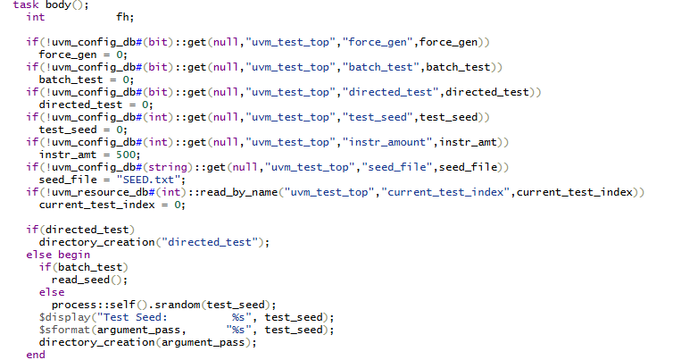
Figure 53: RV32I_driver code
The task body() initializes test parameters, decides on the test mode (fixed, batch, or random), and sets up the test environment appropriately, ensuring flexibility and configurability for RV32I sequence testing.

3.2.3.2 RV32I driver
The RV32I driver serves as a bridge between the sequence's higher-level abstraction (which defines RV32I instructions) and the low-level signals that directly control the processor model or DUT. It takes transaction items (rv32i_seq_item) from the sequence and converts them into control signals or transactions that the DUT understands. Below is the code of the run_phase part of rv32i_driver.
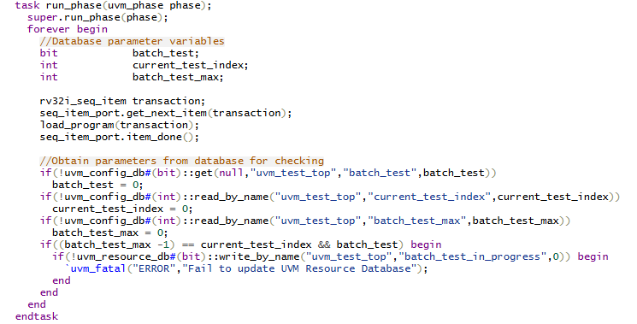
Figure 54: RV32I_driver code
The run_phase task is in charge of continually processing transaction items from the sequence, loading them into the DUT, and handling specific configuration parameters contained in the UVM database. RV32i driver transaction handling:
- Retrieves a transaction (rv32i_seq_item) from the sequence.
- Loads the transaction into the DUT using load_program(transaction).
- Signals completion with seq_item_port.item_done().

3.2.3.3 RV32I monitor

The RV32I monitor component records the information transmitted to the interface. RV32I monitor component translates recorded signals into transactional data, which is then exported to the scoreboard. Monitor component captures model signals and exports them to other components through an analysis port, as seen in the code segment below.

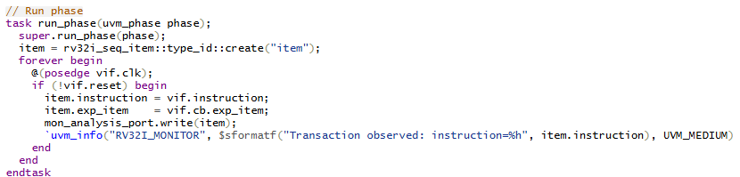
Figure 55: RV32I_monitor code
In the run_phase, the monitor begins monitoring the DUT's behavior with an infinite begin loop. When it receives a posedge pulse from “vif.clk”, the monitor examines the conditions to record the transaction.
Condition if (!vif.reset) to check whether the reset signal is enabled. Otherwise, the monitor will continue to process. Assign value to item. Take the value of vif.instruction and vif.cb.exp_item and assign it to the item. Send the transaction to communicate this transaction item to other testbench components for analysis and testing, call mon_analysis_port.write(item).
Before sending a transaction, the monitor uses `uvm_info to notify the observed transactions, providing details such as the value of the instruction.

3.2.3.4 RV32I agent
rv32i_agent is a UVM agent component that organizes and manages communication and testing between the testbench and the DUT using the RV32I architecture. It has sequencer, driver, and monitor components that manage transaction creation and submission to the DUT, as well as monitoring and recording DUT operations for analysis and reporting of results during hardware testing.
Connecting components during the “connect_phase” guarantees that they operate effectively and correctly on the testbench.

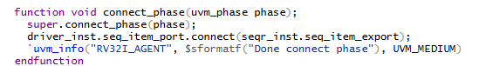

Figure 56: RV32I_agent code
It connects the driver's sequence item port (seq_item_port) to the sequencer's sequence item export. This link allows the sequencer to send transaction items directly to the driver, which is critical for operating the DUT. Logs an informational message stating that the connect step has finished successfully, which helps with debugging and verification of the setup procedure.

3.2.3.5 RV32I environment
The rv32i_env module contains a full testing framework for the RV32I DUT, ensuring a thorough validation process by coordinating the sequencer, driver, monitor, and scoreboard. This environment offers both directed and random test sequences, allowing for complete evaluation of the DUT's functionality and performance.
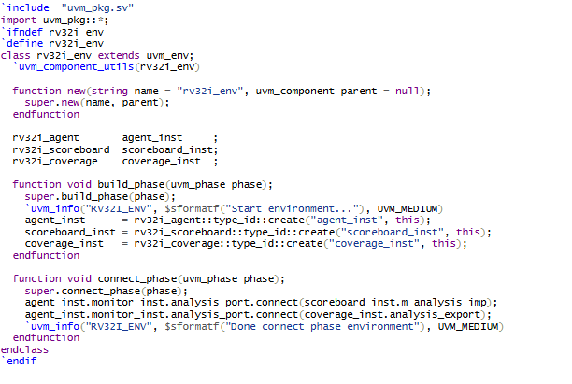
Figure 57: RV32I_env code
The rv32i_env class creates a UVM environment for testing the RV32I microprocessor design. It includes the necessary elements such as agency, scoreboard, and coverage. These components are initialized during the build phase, and then connected to one another during the connect phase to ensure correct communication and interaction in the test environment. This configuration makes it easier to test the RV32I microprocessor design with UVM.
- The build_phase function
+ The build_phase parameter is used in UVM's build process.
+ This code creates instances of the modules agent_inst, scoreboard_inst, and coverage_inst using UVM factory.
- The connect_phase function
+ The connect_phase function is used during the UVM connect phase.
+ This function connects the components' ports and exports, ensuring that they communicate.

3.2.3.6 RV32I test
The rv32i_test class provides the framework for testing the RV32I microprocessor design, which includes the test environment, transaction sequences, and virtual interfaces. During the construction phase, various components are initialized and configured. During the run phase, the transaction sequences are initialized and the test is performed. The random_test class enhances rv32i_test by providing transaction sequence randomization capability to build customized tests using random transactions.
This arrangement allows for direct and random testing, which aids in the detection and correction of problems in the RV32I design.

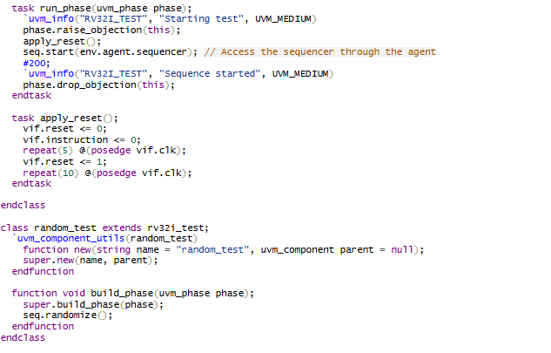
Figure 58: RV32I_test code
The “random_test” class implements a random test for the RV32I microprocessor design. During the “build phase”, the function is invoked to randomize the seq transaction sequence, resulting in a diversified and wide set of tests to ensure that the design is accurate.

3.2.3.7 RV32I interface
The defined RV32I interface is intended to facilitate communication and data exchange among various components in the UVM (Universal Verification Method) test environment. The RV32I UVM uses the interfaces listed in the table below.

Port name | Direction | Bit width | Description
Clock and Reset
clk | Input | 1 | Clock 400MHz
reset | Input | 1 | Reset syn to 400MHz
instr_addr | Input | 32
instr_code | Input | 32
mismatch_detected | Output | 1
Signals from Design Under Test (DUT)
dut_instr | Input | 32 | The current instruction being executed by the RV32I
dut_pc | Input | 32 | Program Counter value
dut_reg_read_addr_1 | Input | 5 | Address of the first register being read
dut_reg_read_addr_2 | Input | 5 | Address of the second register being read
dut_reg_write_addr | Input | 5 | Address of the register being written to
dut_reg_read_data_1 | Input | 32 | Address of the register being written to
dut_reg_read_data_2 | Input | 32 | Data from the second register being read
dut_reg_write_data | Input | 32 | Data being written to the register
dut_ctl_op | Input | 8 | Control opcode for ALU operations
dut_alu_zero | Input | 1 | ALU zero flag
dut_alu_output | Input | 32 | Output result of the ALU
dut_imm_val | Input | 32 | Immediate value from the instruction
dut_mem_write_data | Input | 32 | Data to be written to memory
dut_mem_addr | Input | 16 | Memory address being accessed
Signals from Reference Model
ref_instr | Input | 32 | Current instruction according to the ref
ref_pc | Input | 32 | Program Counter value according to the ref
ref_reg_read_addr_1 | Input | 5 | Address of the first register being read
ref_reg_read_addr_2 | Input | 5 | Address of the second register being read
ref_reg_write_addr | Input | 5 | Address of the register being written to
ref_reg_read_data_1 | Input | 32 | Data from the first register being read
ref_reg_read_data_2 | Input | 32 | Data from the second register being read
ref_reg_write_data | Input | 32 | Data being written to the register
ref_ctl_op | Input | 8 | Control opcode for ALU operations
ref_alu_zero | Input | 1 | ALU zero flag
ref_alu_output | Input | 32 | Output result of the ALU
ref_imm_val | Input | 32 | Immediate value from the instruction
ref_mem_write_data | Input | 32 | Data to be written to memory
ref_mem_addr | Input | 32 | Memory address being accessed
ref_mem_write | Input | 32 | Memory writes signal
ref_mem_read | Input | 32 | Memory read signal
ref_reg_write | Input | 32 | Register write signal

Table 1 RV32_interface table
The rv32i_if interface encapsulates all signals required to monitor and drive both the DUT and the reference model. This encapsulation simplifies the testbench architecture by making connections simpler and the code easier to manage. The interface improves modularity and reusability, both of which are important principles in effective verification environments, by grouping related signals together. The following code segment shows the RV32I interface component:

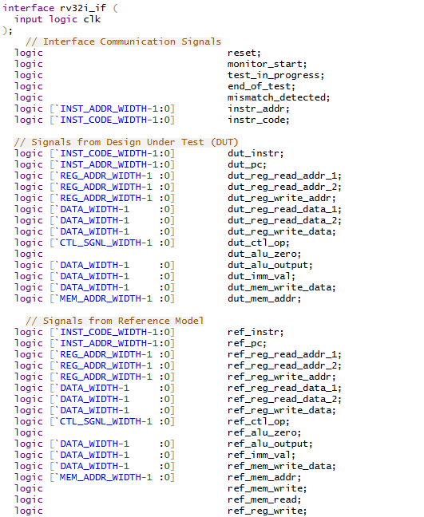
Figure 59: RV32I interface code
For signal interfaces that have large bit widths and often change during development, these interfaces will be defined with these parameters and those parameters will be specified in the “parameter_list.sv” file.

3.3.3.8 RV32I scoreboard

The rv32i_scoreboard component is intended to test the functioning of a microprocessor design using the UVM framework. The rv32i_scoreboard code includes pre_phase and build_phase:

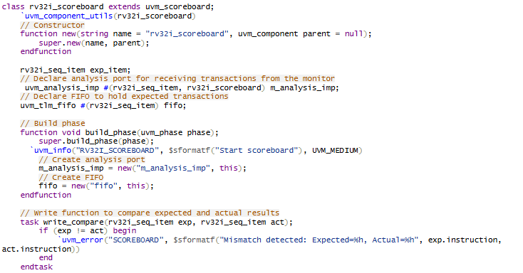

Figure 60: RV32I scoreboard code example 1
Several essential member variables exist in the class. The exp_item is used to store the intended transaction for comparison. The m_analysis_imp is an analysis port that receives transactions from the monitor and allows the scoreboard to communicate with other UVM components. The fifo is a FIFO queue that stores expected transactions and ensures that they are executed in the proper sequence.
During the build phase, the analysis port and FIFO are established. The m_analysis_imp is formed to receive transactions, and the fifo is set up to store the expected transactions. This configuration is critical for the scoreboard's operation since it prepares the required components for transaction processing.

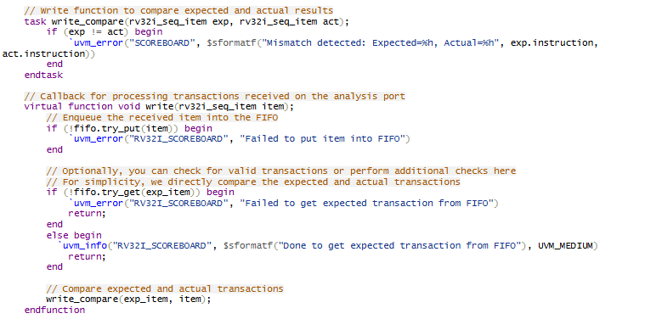

Figure 61: RV32I scoreboard code example 2
The write_compare function is responsible for comparing expected behavior with actual behavior. Determine whether expected behavior matches actual performance. If a mismatch is detected, an error message is written. This process ensures that any differences between predicted and observed behavior are identified and reported.
The write method handles transactions that arrive on the analysis port. When a transaction arrives, it is queued into the FIFO. The procedure then pulls the expected transaction from the FIFO and invokes the write_compare task to comparison the expected and actual transactions. This flow ensures that every transaction is correctly processed and verified.

3.2.3.9 RV32I testbench top
The following code creates a test environment for the RV32I processor using System Verilog and the UVM. This environment includes setting up the clock and reset signals, connecting with the DUT via a virtual interface, and integrating into the UVM environment to run tests.

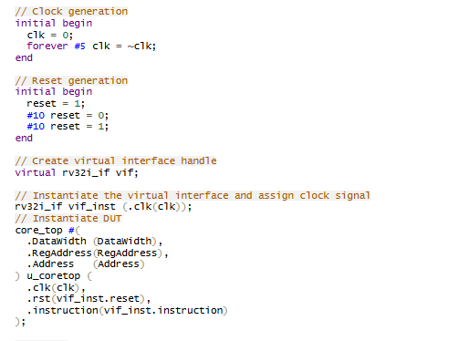

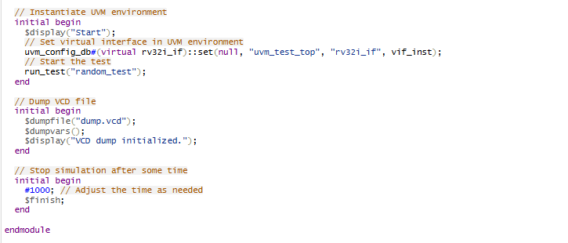
Figure 62: RV32I testbench code
This testbench configuration initializes the appropriate signals (clk and reset), connects to the DUT via a virtual interface (rv32i_if), instantiates the RV32I processor (core_top), and integrates it into a UVM-based environment for running test scenarios (random_test). It provides a structured approach for testing the functioning of the RV32I processor design in a controlled simulation environment.

3.2.4 RV32I instruction code generation
When the simulation starts, the testbench initializes all of the components and verification models. The models are initially applied with a reset signal, which stops them until the verification environment completes the test case configuration. While the reset signal is asserted, the driver component sends a chaining request, asking the formation of chain items that will be used to deliver instructions to the models. When the instructions are completed, a data transaction signaling their completion is transmitted to the driver. The method utilized ensures that the complete program instructions are created before the models begin running.
In contrast to typical transaction-by-transaction simulation, having the whole program available allows the pipelined processor to execute leaps or branches without crashing. In the case of jump or branch instructions, the opcode at the specified destination address must be available in the instruction memory on the following clock cycle. In traditional transaction-to-transaction simulation, opcodes are generated and supplied to the models as prompted, which might result in incorrect test cases if the models seek to access opcodes at an instruction address that the testbench did not generate.
The instruction is created by concatenating the generated command fields in the proper sequence based on the command type. To improve test case quality, a restriction is added to branch commands to limit their scope. The code below demonstrates how the generated command fields are transformed into code:

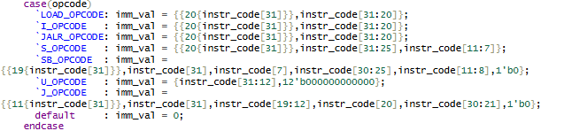

Figure 63: RV32I sequence item code

3.2.5 RV32I reference model impletation

3.2.5.1 Program counter reference model
The ref_pc.sv module will reference the function of the RV32I core program counter block in the RV32I UVM testbench. Below is the code of the ref_pc.sv module.
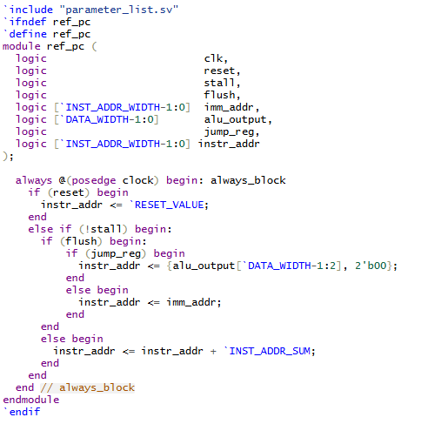
Figure 64: Program counter ref_model
“ref_pc” module behavior summary:
- Reset Condition:
+ When reset is asserted (reset = 1), instr_addr is changed to RESET_VALUE.
+ Sets the program counter to a predetermined beginning point, usually the reset vector.
- Non-Stall Condition (stall)
+ If stall is not asserted (stall = 0), instr_addr may be changed.
- Flush Condition:
+ When flush is claimed (flush = 1).
- Determines how to update the instr_addr:
- Jump Register (Jump_Reg): If jump_reg is asserted (jump_reg = 1), instr_addr is updated using alu_output with a 4-byte boundary.
- Immediate Address (Imm_addr): If jump_reg is not asserted (jump_reg = 0), set instr_addr to imm_addr. Handles branching or jumping straight to a specific address.
- Normal increments (!flush):
+ If flush = 0 and stall = 0, instr_addr is incremented by INST_ADDR_SUM.
+ Supports sequential execution by advancing instr_addr according to the size of the instruction.
The ref_pc module manages the program counter of an RV32I processor. It handles resets, stalls, branch/jump flushes, and typical instruction sequencing. This behavior ensures that control flow within the CPU follows the RV32I instruction set design.

3.3.5.2 Immediate memory reference model
The ref_i_mem module is a simplified instruction memory module in a RV32I design. It retrieves instruction codes from a ROM (rom) using the input instruction address (instr_addr) and assigns the retrieved instruction code to instr_code. Below is the code of the ref_i_mem.sv module.

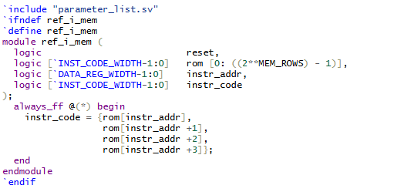
Figure 65: Immediate memory reference model
“ref_i_mem” module behavior summary:
- Fetching instructions from ROM:
+ The ref_i_mem module retrieves instruction codes from a ROM (ROM) using instr_addr.
- Reset Condition:
+ When reset is asserted (reset = 1), ref_i_mem's behavior does not clearly define reset functionality for instr_code. In a ROM-based instruction memory, reset is typically used to initialize internal states or remove temporary storage, but it is not used to reset the fetched instruction codes (instr_codes).
- Non-Stall Condition (stall)
+ If stall is not asserted (stall = 0), the ref_i_mem module will function normally.
- Flush Condition:
+ When flush is asserted (flush = 1), the module does not define how to update instr_code directly. Because ROM contents are often static and read-only, flushing may not have a direct impact on instruction fetching in most cases.
- Instruction Fetching Behavior (always_FF block):
+ The always_ff block continuously adjusts instr_code in response to changes in instr_addr:{rom[instr_addr],rom[instr_addr+1], rom[instr_addr+2], rom[instr_addr +3]}. Concatenates four consecutive values from the rom beginning with instr_addr to form instr_code.
This module is crucial to a processor's instruction fetch and execution pipeline, ensuring that instructions are correctly and efficiently acquired from ROM for further processing and execution.

3.3.5.3 Register file reference model
The ref_reg_file module denotes a register file in RV32I rtl design. It controls 32-bit registers (register) using control signals such clock (clk), reset (reset), instruction code (instr_code), and inputs for reading and writing registers (reg_read_addr_1, reg_read_addr_2, reg_data_1, reg_data_2). Below is the code of the ref_reg_file.sv module.

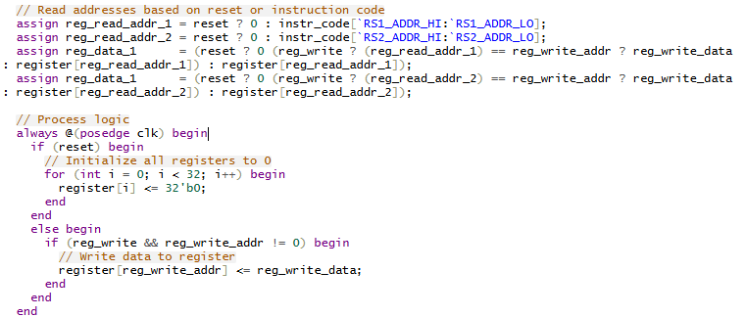
Figure 66: Register file reference model
“ref_reg_file” module behavior summary:
- Read data assignment
+ Reg_data_1 and reg_data_2 are assigned based on the following: If reset is true, initializes to 0.Otherwise, determine whether reg_write is true and the reg_write_addr matches reg_read_addr_1 or reg_read_addr_2. If true, assigns reg_write_data (the write operation). Otherwise, read from the register array using reg_read_addr_1 or reg_read_addr_2.
- Process logic (always_ff Block) executes on the positive edge of clk.
+ If reset is asserted, all registers (register) are initialized to 0.
+ If not in the reset state, determine whether reg_write is asserted and reg_write_addr is not 0.
+ If true, write reg_write_data to the register indicated by reg_write_addr.
Referencing the RV32I DUT design, the ref_reg_file module is responsible for reading and writing to the register file. It initializes the registers on reset, allows reads based on instr_code, and allows data to be written to the registers on positive clock edges.

3.2.5.4 Control unit reference model
The ref_ctl_unit module serves as a control unit for processor designs. It decodes the instruction code (instr_code) to find the control signals (ctl_op) and ALU operations (alu_op) needed to execute the instruction.

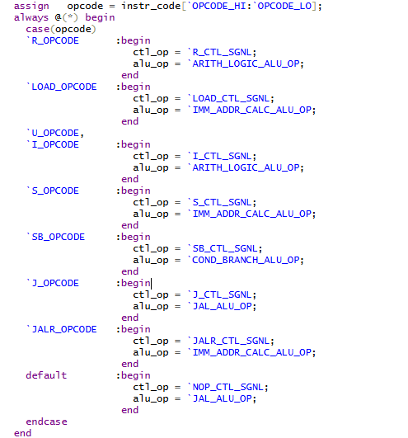
Figure 67: Control unit reference model
“ref_ctl_unit” module behavior summary:
- Opcode Decoding:
+ “opcode” is assigned the value extracted from “instr_code” using the specified range (OPCODE_HI to OPCODE_LO).
- Control and ALU Operation Assignment:
+ “always @(*) begin” defines a combinational logic block sensitive to changes in any input (*).
+ “case(opcode)” evaluates “opcode” to determine which instruction category (opcode) is being processed.
+ Each case branch assigns appropriate values to “ctl_op” and “alu_op” based on the decoded “opcode”.
+ “default” case handles any unrecognized or undefined opcodes, assigning default control signals and ALU operations.
The ref_ctl_unit module decodes instruction codes (instr_code) and outputs the relevant control signals (ctl_op) and ALU operations. It employs a combinational always block to map each opcode to its corresponding control and ALU action, ensuring that instructions are executed correctly in the processor.

3.2.5.5 Immediate generation reference model
The ref_imm_gen module generates instant values (imm_val) using the instruction code (instr_code). It retrieves and prepares instantaneous values from various opcode types for use in instruction execution.

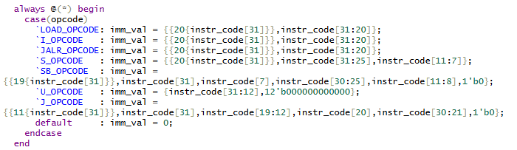
Figure 68: Immediate generation reference model
Immediate value generation:
- “always @(*) begin” defines a combinational logic block sensitive to changes in any input (*).
- “case(opcode)” evaluates opcode to determine which instruction category (opcode) is being processed.
- Each case branch calculates “imm_val” based on the opcode-specific format: LOAD_OPCODE, I_OPCODE, JALR_OPCODE, S_OPCODE, SB_OPCODE, U_OPCODE, J_OPCODE handle different opcode types and extract immediate values accordingly.
- default case assigns “imm_val” to 0 for unrecognized or undefined opcodes.
The ref_imm_gen module effectively extracts and formats immediate values (imm_val) from the instruction code (instr_code) using opcode-specific criteria. It employs a combinational logic approach to decode opcodes and generate immediate values, hence facilitating the accurate execution of instructions in a processor design.

3.2.5.6 ALU control reference model
The ref_alu_ctl module acts as a control unit, determining the appropriate ALU control signal (alu_ctl) based on the instruction operation (alu_op) and instruction code. It decodes the instruction and selects the ALU operation to conduct.
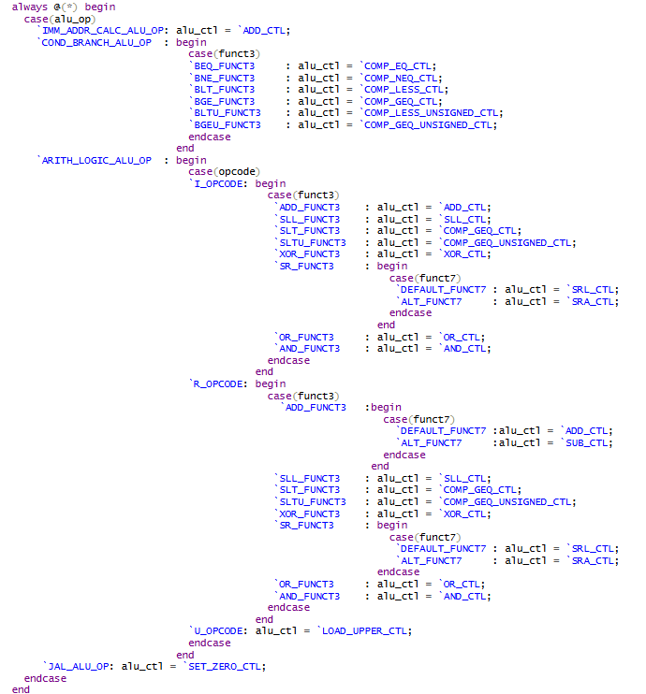
Figure 69: ALU control reference model
ALU control signal assignment:
- “always @(*) begin” defines a combinational logic block sensitive to changes in any input (*).
- “case(alu_op)” evaluates “alu_op” to determine which ALU operation (alu_ctl) is being processed.
- Within each case branch:
+ For IMM_ADDR_CALC_ALU_OP, it assigns ADD_CTL.
+ For COND_BRANCH_ALU_OP, it further evaluates funct3 to determine the specific comparison control signal (COMP_EQ_CTL, COMP_NEQ_CTL, etc.).
+ For ARITH_LOGIC_ALU_OP, it evaluates opcode and funct3 to assign appropriate ALU control signals (ADD_CTL, SLL_CTL, COMP_GEQ_CTL, etc.).
+ JAL_ALU_OP assigns SET_ZERO_CTL.
The ref_alu_ctl module efficiently decodes the instruction code (instr_code) and ALU operation (alu_op) to determine the correct ALU control signal (alu_ctl). It employs combinational logic to manage various instruction types and opcode combinations, ensuring proper ALU operation selection for instruction execution in a RV32I design.

3.2.5.7 Data memory reference model
The ref_d_mem module communicates with data memory (ram) and allows for operations such as read (mem_read) and write (mem_write). It translates instruction codes (instr_code) to determine memory access kinds (byte, half-word, word) and handles data loading (loaded_data) and storing (stored_data) appropriately.
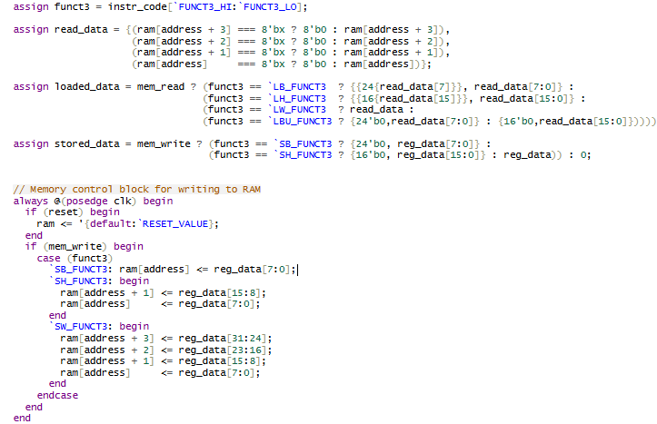
Figure 70: Data memory reference model
“ref_d_mem” module behavior summary
- Read data assignment:
+ “read_data” concatenates bytes from “ram” based on the address to form a 32-bit data (DATA_WIDTH).
+ If any byte (ram[address + i]) contains unknown (8'bx) values, it defaults to 8'b0.
- Loaded data assignment:
+ Depending on mem_read and funct3 (instruction type), loaded_data is assigned the data read (read_data) from memory (ram).
+ Byte (LB_FUNCT3, LBU_FUNCT3), half-word (LH_FUNCT3), and word (LW_FUNCT3) operations are supported, ensuring correct sign extension or zero extension as required.
- Stored data assignment:
+ Depending on mem_write and funct3 (instruction type), stored_data is assigned reg_data to be written to ram.
+ Byte (SB_FUNCT3), half-word (SH_FUNCT3), and word (SW_FUNCT3) operations are supported, formatting reg_data appropriately for storage.
- Memory write control block:
+ “always @(posedge clk)” triggers on positive clock edges.
+ “reset” initializes “ram” to default values (RESET_VALUE).
+ During “mem_write”, based on “funct3”, “reg_data” is written to “ram” at the specified “address”.
+Supports byte (SB_FUNCT3), half-word (SH_FUNCT3), and word (SW_FUNCT3) write operations by updating appropriate bytes in “ram”.
The ref_d_mem module handles data memory operations in a processor design, including read and write operations based on instruction codes and control signals. It interprets instr_code and ensures correct data formatting (loaded_data and stored_data) for memory transactions. This module is required for executing memory-related instructions in an RV32I DUT implementation.

3.2.6 DUT-Testbench Connections.
UVM testbench objects cannot directly drive or sample DUT signals. The communication between an agent's driver, monitor component objects, and the DUT is routed through static signal ports on RV32I DUT components. RV32I DUT components can be built as modules or interfaces. To connect to a UVM monitor or driver component class, a SystemVerilog virtual interface handle is used to reference the static interface content.
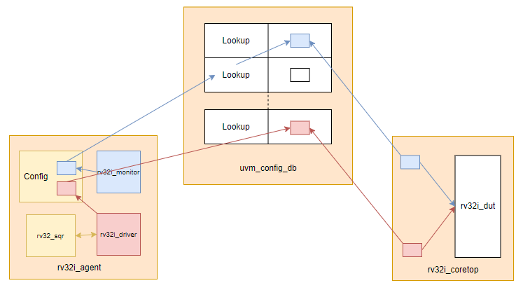
Figure 71: RV32I_UVM connect diagram
This overview demonstrates how the agent monitor and driver UVM objects reference concrete rv32i interfaces in the core top via virtual interface handles in the uvm_config_db database.
The uvm_config_db utility class transfers configuration data across components in a UVM testbench. The uvm_config_db function requires the type of the data item being stored or retrieved. The uvm_config_db has two methods: “set()” for storing objects and “get()” for retrieving them. Both methods require arguments to assign an object, associate it with a lookup key, and specify which components in the RV32I UVM testbench hierarchy can reference model RV32I DUT feature. Below is the “build_phase” in rv32i_monitor using uvm_config_db is used to retrieve the virtual interface (vif) from the UVM configuration database.

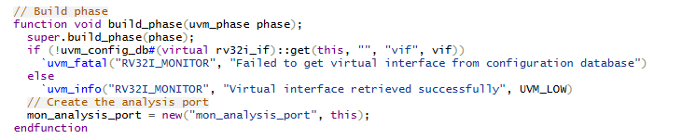
Figure 72: RV32I build phase connection

CHAPTER 4. RESULT

4.1 Design error detection
RV32I UVM compares the internal states of the design under test to those of the reference model. To evaluate the fault detection capacity of the applied design verification method, flaws are intentionally or unintentionally introduced into the design under test.
In the first test, a fault is injected into the program counter's source code to assess its self-detection capabilities. Change the initial increment to 5 and test as shown in the code below.

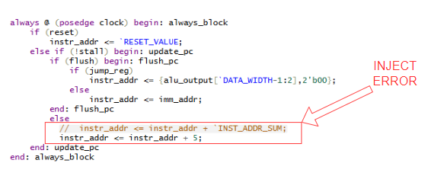

Figure 73: Inject error into code DUT
After running the simulation, UVM reported a fatal error and stopped the simulation immediately because it detected a serious error. Below is an image of when uvm_fatal and the simulation stopped immediately.

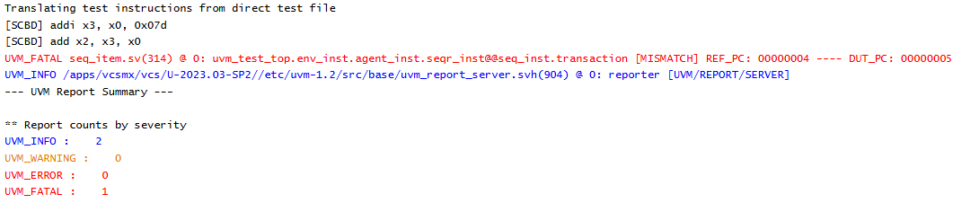

Figure 74: UVM error message
If we detect the error that UVM detects and then find and fix the error correctly, we will no longer encounter the uvm_fatal error as above and uvm will report that they match as shown in the image below.
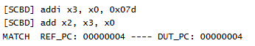
Figure 75: UVM no error message

4.2 Directed testcase
A directed verification scheme was employed to verify against the following criteria:
- All instructions are functional
- Data is forwarded.
- Memory accesses are mismatched.
Let’s start with the case of passing only one instruction and end up. We will pass an ASM instruction “ addi x3, x0, 125” which will assign the value 125 from the default address x0 to the next address x3.
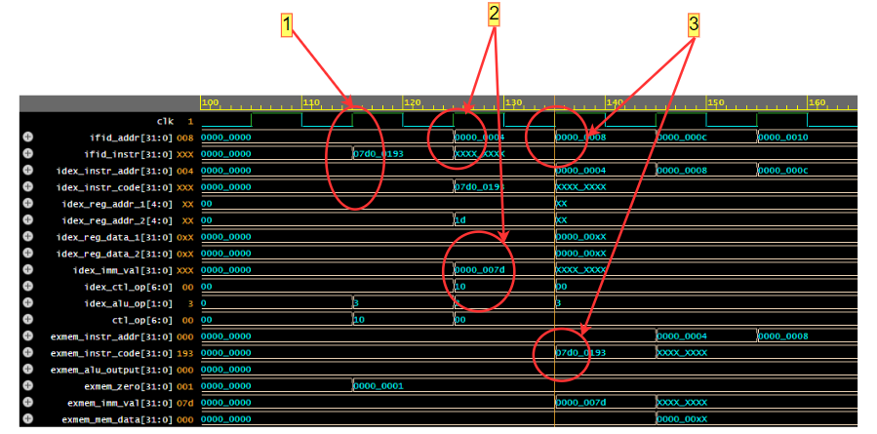
Figure 76: Waveform for single instruction
A cycle of executing an instruction after going through 3 stages pipeline out of 5 stages is shown through the waveform in Figure 4.2.1. It can be seen that at time (1), the instruction is put into the ifid_instr signal when the clk pulse has a rising edge. At this time, the system will wait for the next rising edge to continue performing the task. At time (2), because there is no other instruction entered, the ifid_instr signal is in an indeterminate state. At time (2), when the clk pulse just rises, the value d'125 is saved into the idex_imm_val signal as shown in the figure. Finally, at time (3), the instruction has been put into the exmem_instr_code signal in the 3rd stage pipeline. It can be seen that the instruction processing flow is following the original idea that UVM put in. This proves that the DUT is correct with the function that this test checks, which is to execute the instruction to assign 125 to address x3.

In the case of entering 3 instructions as shown below: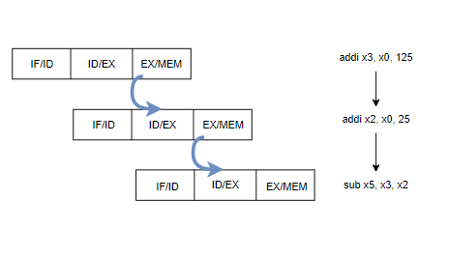
Figure 77: Order of giving 3 consecutive instructions
From figure 77, we can see that the scenario of this testcase is to continuously send clk by clk 3 instructions. The first instruction assigns 125 to address x3, the next assigns 25 to address x2, and finally subtracts x2 from address x3. Below is the waveform when simulating this testcase.
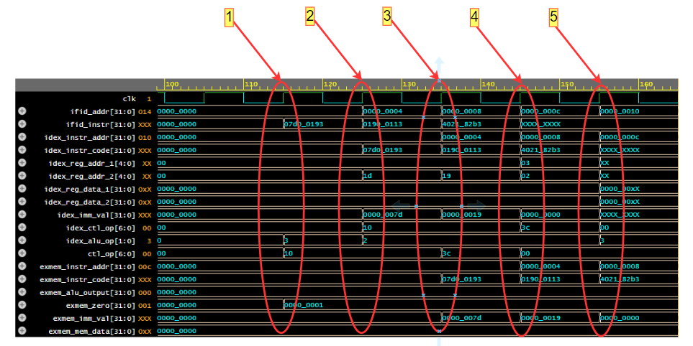

Figure 78: Waveform for 3 consecutive instructions
With the test scenario of 3 consecutive instructions shown in Figure 4.2.3, it shows that after each clk, the system will pipeline once. At time (1), the first instruction is written to the ifid_instr signal of the IF/ID stage and ends at this clk. At time (2), the clk pulse rises, the next instruction is simultaneously inserted into the ID/EX stage, putting the imm_val value of the first instruction into address x3 from address x0. At time (3), the third instruction is inserted and at the same time the imm_val of the second instruction is inserted into the address according to the specified instruction and the first instruction is inserted into the exmem_instr_code signal of the EX/MEM stage. Thus, at times (4) and (5), the execution flow continues similarly to the previous time. At time (5), because there are no more instructions being input, the ifid_instr signal of the IF/ID stage is in an indeterminate state, while the other stages continue to execute all the instructions that have been input until the end of the simulation. From the results of the above test case, it can be seen that for many input instructions, the functionality of the RV32I is clearly demonstrated and is correct as described.
Waveform debugging enables a considerably more extensive analysis and troubleshooting procedure. If no logic flaws are found in the results, such comprehensive investigation may be unnecessary. The test log makes it easier to analyze specific internal design states, allowing for analysis and verification of test results without the need for waveform debugging. Based on the guided verification and analysis of the test findings, the RISC-V pipeline processor is within specification and hence acceptable.

4.3 Random testcase
For the random test case, when running, we will enter the option "RANDOM_TEST" so that the random_test variable is turned on to the value 1 and at this time in the sequencer module, the instructions will be randomly generated through the logic code below:
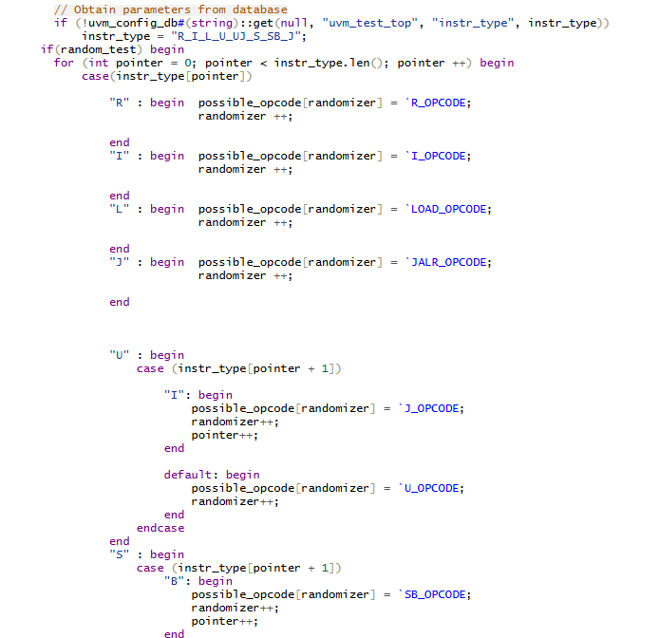

Figure 79: Random test code generation

After running the simulation for the random test case with a large number of instructions, UVM will report no error if the DUT side does not encounter any errors with the cases where the instructions are randomly entered as shown below:

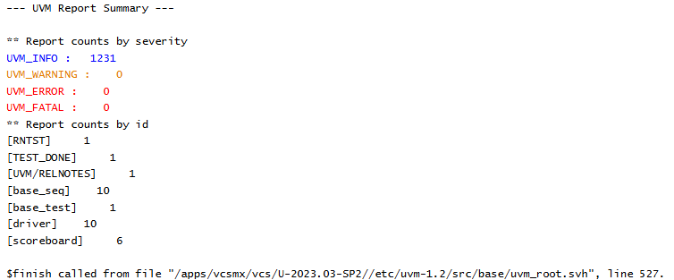

Figure 80: Random test UVM message
At this time, when checking the wave, we will see many instructions being executed continuously over time without interruption because there are no errors during the simulation process as shown below:

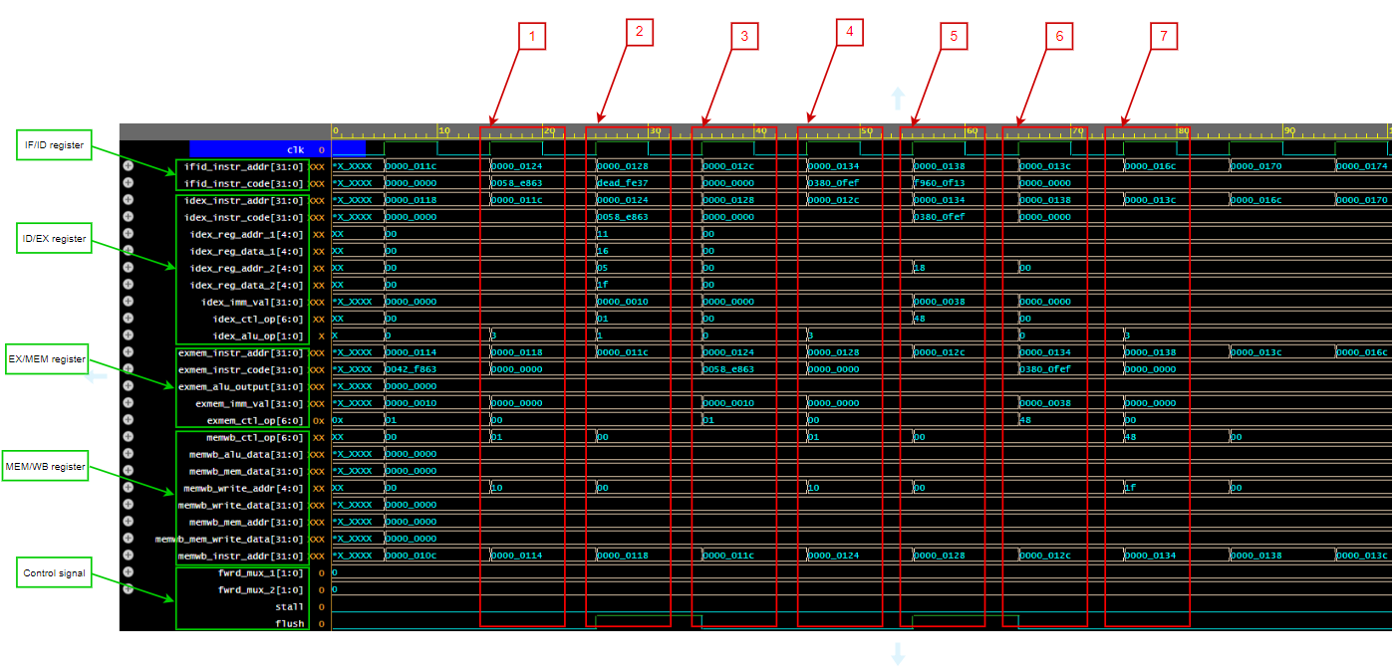

Figure 81: Random test waveform
As shown in Figure 81, all 5 pipelines stages of simulation of RV32I can be seen during the simulation. With instruction 0x0058_e863, at time (1), at IF/ID pipeline stage both instruction code and addr are written to the memory to prepare for decoding, at the same time other stages will continue to execute the previous instructions. Next at time (2), at ID/EX pipeline stage instruction 0x0058_e863 will start to be decoded at this stage and execute arithmetic or logic instructions after being decoded based on the opcode. At time (3), at EX/MEM pipeline stage, instruction 0x0058_e863 completes execution of arithmetic and logic instructions based on the opcode and performs memory access operations. At time (4), after completing execution and accessing the memory, instruction 0x0058_e863 will be saved to the destination record based on the opcode in MEM/WB pipeline stage. Besides, the instructions written in the IF/ID stage where the flush signal is turned on will be deleted during the simulation process and will not be written into the program counter or executed in other steps. This is also a basic function of RV32I.
Overview of the 5 stages:
- Time 1: IF - Instruction 0x0058_e863 is loaded from memory into the IF/ID register.
- Time 2: ID - Instruction 0x0058_e863 is decoded and moved to the ID/EX register.
- Time 3: EX - Performs arithmetic or logic operations and moves to the EX/MEM register.
- Time 4: MEM - Performs memory access operations if necessary and moves to the MEM/WB register.
- Time 5: WB - Writes the result back to the destination register.
Instruction 0x0058_e863 goes through each stage of the RV32I pipeline, from instruction fetch (IF) to decode (ID), execute (EX), access memory (MEM), and finally write result (WB). Control signals and branch or jump address calculations ensure that the instruction is executed correctly and efficiently in each clock cycle.
After running and testing through random test cases, we can temporarily conclude that the basic DUT of RV32I design has performed the basic inherent functions. Next, to delve into advanced and special functions, we need to have additional upgrades for RV32I UVM.

CHAPTER 5. CONCLUSION AND FUTURE WORK

5.1 Conclusion
After evaluating the results and performance of the RV32I UVM (Universal Verification Method) techniques, the following advantages can be seen:
RV32I UVM approaches are important in the subject of ubiquitous processing verification, and they are widely investigated and employed in academia and industry. During the student research, these strategies were investigated at the academic level, with an emphasis on conflict theories and implementations in simplified settings. In this project, we expanded these ideas to create a more complicated and practical design. Although the project is primarily about research and assessment, it also delivers ideas and approaches that are applicable to real-world problems. The usage of industry standard tools has further broadened our practical understanding and experience with the chip design and verification process.
Overall, the project has effectively achieved its initial goals. UVM techniques were successfully used to test the basic RV32I processor, leading to significant gains in validation coverage and efficiency. Furthermore, the incorporation of these methodologies into the validation environment did not result in functional validation errors. The final verification results satisfy the requirements for comprehensive processor verification.

5.2 Future Work
To support the learning, research, and development goals in the subject of processor validation, the report recommends numerous directions for future growth of this topic, such as:
Advanced Verification Tools: Using more advanced and specialized verification tools will help you obtain a better grasp of verification difficulties and increase the accuracy of verification outcomes. This can improve the efficiency of UVM procedures and lead to better-optimized validation processes.
Performance Analysis: A processor's performance is critical. It would be beneficial to employ performance analysis tools to assess the influence of validation procedures on processor performance. This would allow for modifications throughout validation planning and execution in order to maximize performance and accuracy.
Applications to multiple architectures: Expand the use of UVM RV32I approaches to various processor architectures in the chip manufacturing sector in general, as well as the front-end of the vlsi design flow.

REFERENCE

[1] Greengard, S. (2020). Will RISC-V revolutionize computing? In Communications of the ACM (Vol. 63, Issue 5, pp. 30–32). Association for Computing Machinery (ACM). https://doi.org/10.1145/3386377
[2] Patterson, D. A., & Hennessy, J. L. (2021). Computer Organization and Design: The hardware software interface. Amazon. https://www.amazon.com/Computer-Organization-Design-RISC-V-Architecture/dp/0128203315
[3] Amruth, M. S. S. D., Swamy, B. P. R., Satyanarayana, CH. M. V., Kumar, B. R., Aarthi, V. P. M. B., & Ramesh, M. (2023). Five Stage Pipelined MIPS Processor Verification Scoreboard Module using UVM. In 2023 International Conference in Advances in Power, Signal, and Information Technology (APSIT). 2023 International Conference in Advances in Power, Signal, and Information Technology (APSIT). IEEE. https://doi.org/10.1109/apsit58554.2023.10201745
[4] Deny, J., Deepika, D. L. S., Lekhana, V., Vandana, G., & Devi, K. G. (2023). Five-Stage Pipelined MIPS Processor Verification Driver Module using UVM. In 2023 International Conference on Sustainable Computing and Smart Systems (ICSCSS). 2023 International Conference on Sustainable Computing and Smart Systems (ICSCSS). IEEE. https://doi.org/10.1109/icscss57650.2023.10169277
[5] Ramesh, M., Charan Kumar, D., Yashwanth, L., Jyoteeswara Reddy, G., Naveen, K., & Pandiaraj, K. (2023). Five Stage Pipelined MIPS Processor Verification Interface and Test Module using UVM. In 2023 International Conference on Sustainable Computing and Smart Systems (ICSCSS). 2023 International Conference on Sustainable Computing and Smart Systems (ICSCSS). IEEE. https://doi.org/10.1109/icscss57650.2023.10169648
[6] Bhuvaneswary, N., Jaswanth, M., Eswar, M., Rajamouli, R., & Reddy, G. V. D. (2023). FIVE STAGE PIPELINED MIPS PROCESSOR VERIFICATION SEQUENCE MODULE USING UVM. In 2023 International Conference on Recent Advances in Electrical, Electronics, Ubiquitous Communication, and Computational Intelligence (RAEEUCCI). 2023 International Conference on Recent Advances in Electrical, Electronics, Ubiquitous Communication, and Computational Intelligence (RAEEUCCI). IEEE. https://doi.org/10.1109/raeeucci57140.2023.10134405
[7] Pandiaraj, K., Kumar, C. P., Attar, M., Naidu, S., & Hajipeera, D. (2023). Five Stage Pipelined MIPS Processor Verification Coverage Module Using UVM. In 2023 9th International Conference on Advanced Computing and Communication Systems (ICACCS). 2023 9th International Conference on Advanced Computing and CommunicationSystems(ICACCS).IEEE.https://doi.org/10.1109/icaccs57279.2023.10112791
[8] Oleksiak, A., Cieslak, S., Marcinek, K., & Pleskacz, W. A. (2019). Design and Verification Environment for RISC-V Processor Cores. In 2019 MIXDES - 26th International Conference “Mixed Design of Integrated Circuits and Systems.” 2019 MIXDES - 26th International Conference “Mixed Design of Integrated Circuits and Systems.” IEEE. https://doi.org/10.23919/mixdes.2019.8787108
[9] Zhang, W., Zhang, Y., & Zhao, K. (2021). Design and Verification of Three-stage Pipeline CPU Based on RISC-V Architecture. In 2021 5th Asian Conference on Artificial Intelligence Technology (ACAIT). 2021 5th Asian Conference on Artificial Intelligence Technology (ACAIT). IEEE. https://doi.org/10.1109/acait53529.2021.9731161
[10] Sun, M., Li, Y., Chen, S., & Kang, Y. (2021). A Low Power Branch Prediction for Deep Leaning on RISC-V Processor. In 2021 International Conference on Control Science and Electric Power Systems (CSEPS). 2021 International Conference on Control Science and Electric Power Systems (CSEPS). IEEE. https://doi.org/10.1109/cseps53726.2021.00025

